Ref: WP2-FSD | Issue Date: 17/02/06 | Version Number: 2.0
Contract REPORTNET 02020400/2004/394786/MAR/G3

Functional specificationS DOCUMENT
for
unified notification service

Written by:  EUROPEAN DYNAMICS S.A.  Mr. Nedeljko Pavlovic | Sign Off and Date:  17/02/06 |  | Appraisal Authority:  EEA  Mr. Stefan Jensen | Sign Off and Date:
Verified by:  EUROPEAN DYNAMICS S.A.  Dr. Zack Protogeros | Sign Off and Date:  17/02/05 |  | Appraisal Authority:  EEA | Sign Off and Date:
Approved by:  EUROPEAN DYNAMICS S.A.  PROJECT MANAGER  Dr. Stelios Papastratos | Sign Off and Date:  17/02/06 |  | Appraisal Authority:  EEA | Sign Off and Date:

Circulation List

Name | Company/Institution
Nedeljko Pavlovic | EUROPEAN DYNAMICS S.A.
Zack Protogeros | EUROPEAN DYNAMICS S.A.
Stelios Papastratos | EUROPEAN DYNAMICS S.A.
Soren Roug | EEA
Stefan Jensen | EEA

Document History

Ver. | Date |  | Confidentiality | Description | Action | Pages
1.0 | 07/03/05 | Normal |  | Release to EEA | C | 57
1.1 | 21/03/05 | Normal |  | Include EEA comments – Clarify non functional requirements | R | 56
1.2 | 15/06/2005 | Normal |  | Changed according to Brussels meeting conclusions | R | 66
2.0 | 17/02/2006 | Normal |  | Updated based on final delivered functionalities | I/R/C | 93
(*) Action: I = Insert; R = Replace; C = Creation

Table of Contents
1 Introduction 9
1.1 Purpose 9
1.2 Document Conventions 9
1.3 Overview 10
1.4 Project Scope 10
1.5 References 11
2 Overall Description 12
2.1 Product Perspective 12
2.1.1 Operating environment 13
2.2 Product Features 13
2.2.1 Administrative features 13
2.2.2 UNS Users features 19
2.2.3 XML-RPC User features 21
2.2.4 Common features 22
2.2.5 System features 23
2.3 User Classes and Characteristics 25
2.3.1 Anonymous User 25
2.3.2 Zope Manager 25
2.3.3 UNS User 25
2.3.4 UNS Administrator 26
2.3.5 XML-RPC User 26
2.4 User Documentation 27
3 Specific requirements 28
3.1 External Interface Requirements 28
3.1.1 User Interfaces 28
3.1.2 Hardware Interfaces 29
3.1.3 Software Interfaces 29
3.1.4 Communications Interfaces 30
3.2 Functional requirements 31
3.2.1 Administrative features 31
3.2.1.1 Manage Pull Event channels 32
3.2.1.1.1 Introduction/Purpose 32
3.2.1.1.2 Stimulus/Response sequence 32
3.2.1.1.3 Associated Functional requirements 32
3.2.1.2 Create content channel 32
3.2.1.2.1 Introduction/Purpose 32
3.2.1.2.2 Stimulus/Response sequence 32
3.2.1.2.3 Associated Functional requirements 33
3.2.1.3 Edit content channel 34
3.2.1.3.1 Introduction/Purpose 34
3.2.1.3.2 Stimulus/Response sequence 34
3.2.1.3.3 Associated Functional requirements 34
3.2.1.4 Remove content channel 36
3.2.1.4.1 Introduction/Purpose 36
3.2.1.4.2 Stimulus/Response sequence 36
3.2.1.4.3 Associated Functional requirements 37
3.2.1.5 Manage Push Event channels 37
3.2.1.5.1 Introduction/Purpose 37
3.2.1.5.2 Stimulus/Response sequence 38
3.2.1.5.3 Associated Functional requirements 38
3.2.1.6 Edit content channel 38
3.2.1.6.1 Introduction/Purpose 38
3.2.1.6.2 Stimulus/Response sequence 38
3.2.1.6.3 Associated Functional requirements 38
3.2.1.7 Remove content channel 40
3.2.1.7.1 Introduction/Purpose 40
3.2.1.7.2 Stimulus/Response sequence 40
3.2.1.7.3 Associated Functional requirements 40
3.2.1.8 Management of the Notifications templates 41
3.2.1.8.1 Introduction/Purpose 41
3.2.1.8.2 Stimulus/Response sequence 41
3.2.1.8.3 Associated Functional requirements 42
3.2.1.9 Create notification template 42
3.2.1.9.1 Introduction/Purpose 42
3.2.1.9.2 Stimulus/Response sequence 42
3.2.1.9.3 Associated Functional requirements 43
3.2.1.10 Edit notification template 45
3.2.1.10.1 Introduction/Purpose 45
3.2.1.10.2 Stimulus/Response sequence 45
3.2.1.10.3 Associated Functional requirements 45
3.2.1.11 Remove notification template 46
3.2.1.11.1 Introduction/Purpose 46
3.2.1.11.2 Stimulus/Response sequence 46
3.2.1.11.3 Associated Functional requirements 46
3.2.1.12 Reports 47
3.2.1.12.1 Introduction/Purpose 47
3.2.1.12.2 Stimulus/Response sequence 47
3.2.1.12.3 Associated Functional Requirements 47
3.2.1.13 Notifications throughput report 48
3.2.1.13.1 Introduction/Purpose 48
3.2.1.13.2 Stimulus/Response sequence 48
3.2.1.13.3 Associated Functional Requirements 48
3.2.1.14 Failed notifications report 49
3.2.1.14.1 Introduction/Purpose 49
3.2.1.14.2 Stimulus/Response sequence 49
3.2.1.14.3 Associated Functional Requirements 49
3.2.1.15 Remove problematic subscription 50
3.2.1.15.1 Introduction/Purpose 50
3.2.1.15.2 Stimulus/Response sequence 50
3.2.1.15.3 Associated Functional Requirements 50
3.2.1.16 Edit Application configuration parameters 51
3.2.1.16.1 Introduction/Purpose 51
3.2.1.16.2 Stimulus/Response sequence 51
3.2.1.16.3 Associated Functional Requirements 51
3.2.1.17 Manage Users 53
3.2.1.17.1 Introduction/Purpose 53
3.2.1.17.2 Stimulus/Response sequence 53
3.2.1.17.3 Associated Functional requirements 53
3.2.1.18 Add UNS Administrator 54
3.2.1.18.1 Introduction/Purpose 54
3.2.1.18.2 Stimulus/Response sequence 54
3.2.1.18.3 Associated Functional requirements 54
3.2.1.19 Create XML-RPC User 55
3.2.1.19.1 Introduction/Purpose 55
3.2.1.19.2 Stimulus/Response sequence 56
3.2.1.19.3 Associated Functional requirements 56
3.2.1.20 Change XML-RPC User password 57
3.2.1.20.1 Introduction/Purpose 57
3.2.1.20.2 Stimulus/Response sequence 57
3.2.1.20.3 Associated Functional requirements 57
3.2.1.21 Remove user 58
3.2.1.21.1 Introduction/Purpose 58
3.2.1.21.2 Stimulus/Response sequence 58
3.2.1.21.3 Associated Functional requirements 58
3.2.2 UNS User 59
3.2.2.1 Subscribe 59
3.2.2.1.1 Introduction/Purpose 59
3.2.2.1.2 Stimulus/Response sequence 59
3.2.2.1.3 Associated Functional requirements 60
3.2.2.2 Unsubscribe 61
3.2.2.2.1 Introduction/Purpose 61
3.2.2.2.2 Stimulus/Response sequence 61
3.2.2.2.3 Associated Functional requirements 61
3.2.2.3 Edit subscription 62
3.2.2.3.1 Introduction/Purpose 62
3.2.2.3.2 Stimulus/Response sequence 62
3.2.2.3.3 Associated Functional requirements 62
3.2.2.4 Define events filters 64
3.2.2.4.1 Introduction/Purpose 64
3.2.2.4.2 Stimulus/Response sequence 64
3.2.2.4.3 Associated Functional requirements 64
3.2.2.5 Edit notification preferences 66
3.2.2.5.1 Introduction/Purpose 66
3.2.2.5.2 Stimulus/Response sequence 66
3.2.2.5.3 Associated Functional requirements 66
3.2.2.6 Manage vacation flag 67
3.2.2.6.1 Introduction/Purpose 67
3.2.2.6.2 Stimulus/Response sequence 67
3.2.2.6.3 Associated Functional requirements 68
3.2.3 XML-RPC User 69
3.2.3.1 Create channel (By using the UNS Web User Interface) 69
3.2.3.1.1 Introduction/Purpose 69
3.2.3.1.2 Stimulus/Response sequence 69
3.2.3.1.3 Associated Functional requirements 69
3.2.3.2 Create channel (By using calling XML-RPC method) 70
3.2.3.2.1 Introduction/Purpose 70
3.2.3.2.2 Stimulus/Response sequence 70
3.2.3.2.3 Associated Functional requirements 70
3.2.3.3 Edit channel 71
3.2.3.3.1 Introduction/Purpose 71
3.2.3.3.2 Stimulus/Response sequence 71
3.2.3.3.3 Associated Functional requirements 71
3.2.3.4 Send notification 72
3.2.3.4.1 Introduction/Purpose 72
3.2.3.4.2 Stimulus/Response sequence 72
3.2.3.4.3 Associated Functional requirements 72
3.2.3.5 Check if user can be subscribed 73
3.2.3.5.1 Introduction/Purpose 73
3.2.3.5.2 Stimulus/Response sequence 74
3.2.3.5.3 Associated Functional requirements 74
3.2.3.6 Make subscription 75
3.2.3.6.1 Introduction/Purpose 75
3.2.3.6.2 Stimulus/Response sequence 75
3.2.3.6.3 Associated Functional requirements 75
3.2.4 Common features 77
3.2.4.1 Authentication/Authorization 77
3.2.4.1.1 Introduction/Purpose 77
3.2.4.1.2 Stimulus/Response sequence 77
3.2.4.1.3 Associated Functional requirements 77
3.2.5 System features 78
3.2.5.1 Pull events data 78
3.2.5.1.1 Introduction/Purpose 78
3.2.5.1.2 Stimulus/Response sequence 78
3.2.5.1.3 Associated Functional requirements 78
3.2.5.2 Run Notifications thread 79
3.2.5.2.1 Introduction/Purpose 79
3.2.5.2.2 Stimulus/Response sequence 79
3.2.5.2.3 Associated Functional requirements 79
3.3 Nonfunctional requirements 81
3.3.1 Software Quality Attributes 81
3.3.1.1 Functionality 82
3.3.1.2 Reliability 84
3.3.1.3 Usability 85
3.3.1.4 Efficiency 86
3.3.1.5 Maintainability 86
3.3.1.6 Portability 87
3.3.2 Design and implementation constraints 87
Appendix A: Screenshots of the UI parts supporting the key requirements. 89
Appendix B: Requirements Traceability Matrix 92

Table of Figures
Figure 1 - Unified Notification Service block diagram 12
Figure 2 - Administrative features groups use case diagram 13
Figure 3 - PULL content channels management use case diagram 15
Figure 4 - PUSH content channels management use case diagram 16
Figure 5 - UI management use case diagram 17
Figure 6 - Configure application use case diagram 18
Figure 7 - Users management use case diagram 19
Figure 8 - Data monitoring/management use case diagram 19
Figure 9 - REPORTNET User features Use Case diagram 21
Figure 10 - XML-RPC User features Use Case diagram 22
Figure 11 - Common features Use Case diagram 23
Figure 12 - Harvester features Use Case diagram 23
Figure 13 - Notifications trhead features Use Case diagram 24
Figure 14 - User classes’ hierarchy Use case diagram 25
Figure 15 - The main screen of the UNS Administrative UI 89
Figure 16 - The main screen of the UNS REPORTNET Users UI 89
Figure 17 - UNS REPORTNET Users UI for choosing channel for subscribe 90
Figure 18 - UNS REPORTNET Users UI for providing subscription details 90
Figure 19 - Administrative UI for the setting up UNS configuration 91

Introduction

Purpose
This document presents the software requirements specifications for the REPORTNET Unified Notification Service system. Its aim is to provide a clear understanding of the software requirements between European Environment Agency and European Dynamics. Moreover, it will allow Software architects and Test designers to design the system and prepare appropriate test design documentation.

Document Conventions

Acronyms/Abbreviations:

EEA - European Environment Agency
UNS - Unified Notification Service
FSD - Functional Specifications Document
EIONET - The European environmental information and observation network
REQ - Each requirement is uniquely identified by REQ and appropriate sequence number
XML - Extensible Markup Language
TCP/IP - Transmission Control Protocol / Internet Protocol
HTTP - Hypertext Transfer Protocol
XML-RPC - Remote procedure calling using HTTP as the transport and XML
as the encoding.
XMPP - Extensible Messaging and Presence Protocol
SMTP - Simple Mail Transfer Protocol
UI - User interface
<TBD> - Tag used for signing requriments that needs more detailed explanations from the side of the EEA

Terminology:

THE SYSTEM SHALL - A required, must-have feature
THE SYSTEM SHOULD - A desired feature, but may be deferred till later
THE SYSTEM MAY - An optional, nice-to-have feature that may never make it to implementation.

Definitions:
Priority - Attribute used to describe importance of requirement. Priority may have a value of HIGH, MEDIUM or LOW which corresponds to the previously introduced terms (SHALL, SHOULD, or MAY).

Overview
In this functional requirements specifications document, section 1 identifies the scope of the system, the purpose of the software, and lists the definitions, acronyms, abbreviations, and reference documents.
Section 2 provides the general factors that affect the product and its requirements, an overview of the system, and a brief description of all the system functions. This section does not state specific requirements. Instead, it provides a background for those requirements. Moreover, section 2 provides an overview of Use Cases that are presented in details in section 3.
Section 3 contains all of the software requirements. This section presents the detailed Use Cases outlined in section 2 with the associated functional requirements. Functionalities in section 3 are classified into Administrative, User, Common and the System features. This section also describes the quality requirements for the UNS.

Project Scope
The purpose of the notification service is to notify users of specific events, as well as the approach of deadlines and dates. The notifications relate to the REPORTNET dataflow collection and handling cycle and users should be able to set up a notification profile in accordance with their personal preferences.

References
The following table presents other documents and Web addresses which this FSD refers to.

Title | Author | Version | Date | Location
Call for Tenders No ENV.G.3/SER/2003/0116 "Technical specifications for the provision of information technology services to support the development of a wider REPORTNET"
Kick-off Meeting Minutes (24/01/2005) | Stelios Papastratos | 1.1 | 08/02/2005 | http://eea.eionet.eu.int/Members/irc/eionet-circle/eionet-telematics/library?l=/reportnet_project/specialist_files/wp01/reportnet-mom-050124-kom/_EN_1.1_&a=d
Development Procedures | Soren Roug | 1.0 | 25/01/2005 | http://eea.eionet.eu.int/Members/irc/eionet-circle/eionet-telematics/library?l=/reportnet_project/specialist_files/wp01/kickoff-rougppt/_EN_1.0_&a=d
List of Questions/Answers - Zope/Python-J2EE Comparison | Nedeljko Pavlovic  Stelios Papastratos | 1.0 | 31/01/2005 | http://eea.eionet.eu.int/Members/irc/eionet-circle/eionet-telematics/library?l=/reportnet_project/specialist_files/wp01/reportnet-wd-kom-v002doc/_EN_1.0_&a=d
Web site design guidelines | EEA |  | 2004 | http://www.eionet.eu.int/software/design

Overall Description

Product Perspective
The Unified Notification Service is a new system that will be part of the EEA REPORTNET system. The UNS will improve cooperation and transparency and will ease retrieval of information from REPORTNET. In addition, the UNS will represent a unique notification system independent of specific data providers. It will allow registration of an unlimited number of event data providers who will have to respect UNS data format. The following block diagram represents an overview of the UNS.

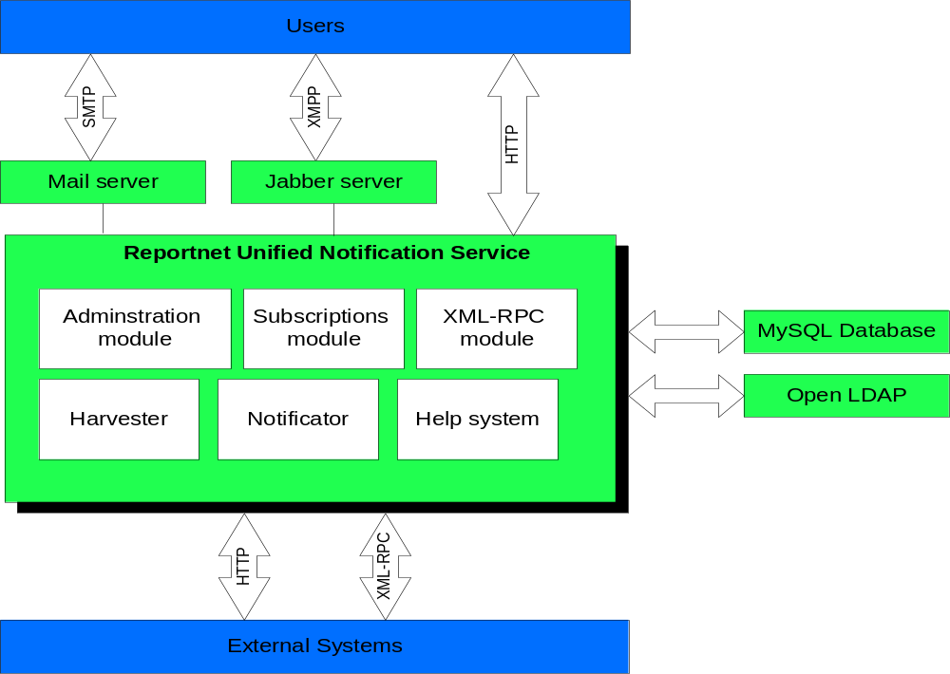

Figure 1 - Unified Notification Service block diagram

Operating environment

- The database management system will be MySQL 4.1
- The UNS will use the web application server ZOPE 2.7.4
- The UNS will operate under Linux OS Red Hat Enterprise 4.0
- The UNS will use the EEA Open LDAP Server 2.0.27
- The UNS will use the Python 2.3.5 (Python 2.4 is officially not* supported because there has not been a security audit for Python 2.4 and Zope 2 so far)

Product Features
There are essentially five main functional areas of the REPORTNET Unified Notification service.

Administrative features
The administrative features of the UNS will allow the UNS Administrators to manage the UNS application. Moreover, these functions will be organized in groups according to the UNS area that will be affected. The functional requirements related to the UNS administrative features are described in section 3.2.1 of this document. The following figure illustrates the groups of the administrative features that will be accessed from the UNS user interface.
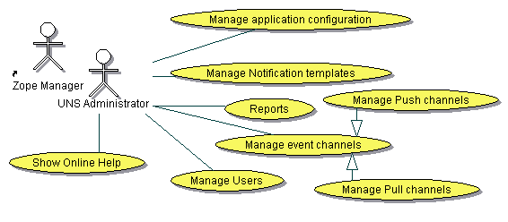

Figure 2 - Administrative features groups use case diagram

The administrative functions of the UNS comply with the following items:
- Management of PULL event channels.
This set of the UNS functions will allow management of the PULL event content channels used for harvesting of the events content data.
  - View Pull channels.
This feature will be responsible for presenting a list of all the existing Pull channels.
  - Create content channel.
This function will allow the creation of event content channels which will be used for harvesting event content data. UNS Users will be able to subscribe themselves to these channels. Each channel will serve only one type of event data.
  - Edit content channel.
This function will allow editing of the existing event content channels.
In case that more restrictive access rights will be defined for specific channel the UNS will send notifications about that change to all subscribed users with lower privileges. More restrictive access right for a user assumes that he/her does not belong to any of EEA user roles associated with the channel.
  - Remove content channel.
This function will allow removal of the existing event content channels.
If there are subscriptions for the channel to be removed the UNS will send notifications to all subscribed users about the channel removal.
  - Define filter elements.
This function will be responsible for defining the meta-data elements that will be used for filtering the events data by UNS Users.
It will be included in the “create content channel” function in the case that an administrator creates a channel in PULL mode. Also it will be included in the “edit existing events content channels” function.

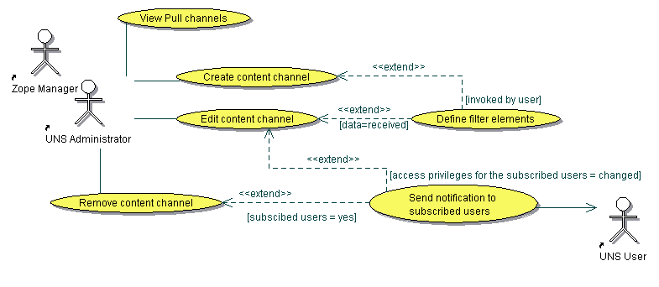

Figure 3 - PULL content channels management use case diagram

- Management of PUSH event channels.
This set of UNS functions will allow management of the PUSH event content channels used for harvesting of the events content data.
  - View Push channels.
This feature will be responsible for presenting the list of all existing Push channels.
  - Enable channel.
This function will allow the UNS Administrators as well as Zope managers to enable Push channels for usage from the external systems.
  - Disable channel.
This function will allow the UNS Administrators as well as Zope managers to disable Push channel. When Push channel become disabled external systems will not be able to send notifications or to subscribe users through it.
  - Edit content channel.
This function will allow editing of the existing event content channels.
In case that more restrictive access rights will be defined for specific channel the UNS will send notifications about that change to all subscribed users with lower privileges.
  - Remove content channel.
This function will allow the removal of the existing event content channels.
If there are subscriptions for the channel to be removed the UNS will send notifications to all subscribed users about channel removal.
  - Define filter elements.
This function will be responsible for defining the meta-data elements that will be used for filtering the events data by UNS Users.
It will be included in the Edit content channel function in order to allow defining allowed filter elements for the channel as well as to redefine existing ones.

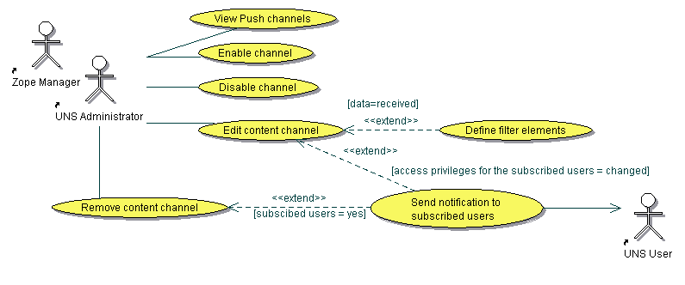

Figure 4 - PUSH content channels management use case diagram

- Manage notification templates
Notifications that the UNS will send to the UNS Users will be generated according to the notification templates. Notification templates will be connected to the event content channels so that the UNS will know what notification template to use while generating the notification for a specific subscription. Initially the UNS will contain three notification templates which can not be deleted but can be modified The UNS Administrators as well as Zope Managers will be able to perform the following functions related to the notification templates:
  - Create notification template.
This function will allow the creation of notification templates which will be used for generating notifications. Each template will have two variants. One is plain/text and second is HTML. The HTML variant of a notification template will be edited by the WYSIWYG editor.
  - Edit notification template.
This function will allow making changes to existing notification templates.
  - Remove notification template.
Removal of the notification template will be allowed only in case that the template is not assigned to any of the existing channels. Removal of the system templates are not allowed also.

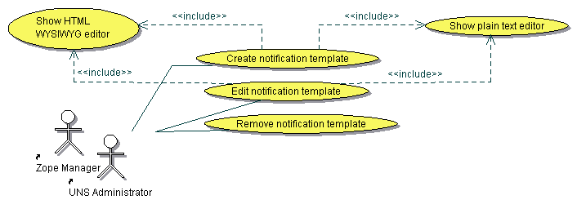

Figure 5 - UI management use case diagram

- Manage application configuration
The UNS Configuration management will allow Zope Managers as well as UNS Administrators to configure an installed Unified Notification Service. The following features will be available:
  - Configure Mail server access parameters.
This feature will allow configuring the access parameters of an email servers. Configuration of the SMTP server (used for sending the e-mail notifications) and POP3 server (used for retrieval of failed e-mail notifications) parameters will be allowed.
  - Configure LDAP server access parameters.
This feature is responsible for configuring the parameters used for access to an LDAP server. The UNS uses the LDPA server for authentication purpose as well as for retreiving users information such as e-mail and user’s EIONET roles.
  - Configure Database server access parameters.
This feature is responsible for setting up parameters used for access to a Database server used for storing the UNS data.
  - Configure Jabber server access parameters.
This feature is responsible for setting up the parameters used for access to a Jabber server that will be used for sending jabber notifications.
  - Control Harvester daemon.
This feature will allow controlling of the UNS Harvester daemon used for harvesting events data through Pull content channels.
  - Control Notifications daemon.
This feature will allow controlling of the UNS Notifications daemon used for generating and sending notifications to users.

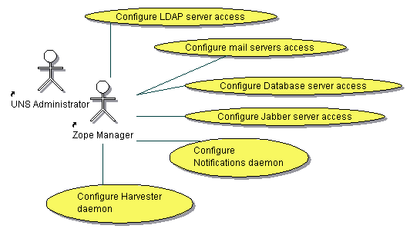

Figure 6 - Configure application use case diagram

- Manage Users.
These features will allow the management of users that belong to UNS Administrator and XML-RPC User roles.
  - Show users list.
This function is responsible for presenting existing users list. If a user with the Zope Manager role access this function all existing users will be presented. If the user of the UNS Administrator role execute this function he/she will be able to see only existing XML-RPC users.
  - Add UNS Administrator.
This function allows adding of the new UNS Administrative users. Those users will be founded inside the EEA LDAP server and assigned to the UNS as UNS Administrators.
  - Create XML-RPC user.
Creates new user of the XML-RPC role.
  - Change XML-RPC user password.
Changes the user’s password.
  - Remove user
Removes an existing user from the UNS.
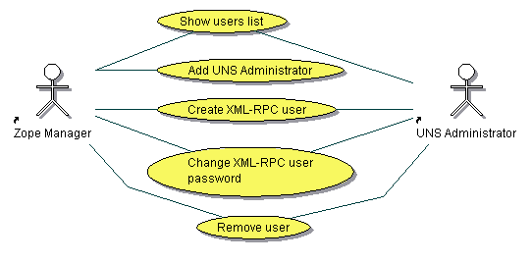

Figure 7 - Users management use case diagram

- Reports.
These features will allow generation of reports related to the number of notifications delivered to the users and failed notifications at the delivery stage. Moreover Zope Managers and UNS Administratros will be able to remove subscriptions which may appear as problematic.
  - Notifications throughput report
  - Failed notifications report
  - Remove problematic notification profile
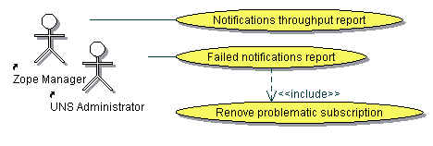

Figure 8 - Data monitoring/management use case diagram

UNS Users features
This set of functions will allow UNS users to manage their notification profile information. More precisely, it will allow registered users to specify what type of notifications they would like to receive. Note that users who belong to the UNS Administrator role inherits same privileges from the UNS User role, therefore those features are also allowed to the UNS Administrators The functional requirements related to the UNS User features are described in section 3.2.2 of this document. The following list represents these functions:
- Manage notification profile
  - Subscribe to an event channel
UNS User will be able to subscribe for receiving notifications from channels that are allowed to his/her role. While subscribing to the channel User will be able to define the so-called “filters” to indicate the UNS what events he/she wants to receive. In addition by using this feature the user will be able to choose how he/she wants to be informed, through jabber, e-mail or the web dashboards. The REPORTNET User will be able to choose the delivery type from the list of allowed delivery types for channel he/she wants to subscribe.
  - Unsubscribe from an event channel.
This function will allow removal of the existing user subscription.
  - Edit existing subscription.
This function will allow the REPORTNET User to edit the existing subscription.
  - Edit Notification Preferences.
The UNS Users will be able to define their own notification preferences by using this feature. The following preferences may be provided to the UNS:
    - User’s jabber address
    - User’s Web Dashboards address
    - Preferred e-mail notification format (Plain text or HTML)
Note that user E-mail address will be automatically detected by the UNS and therefore users will not be allowed to change their e-mail address.
  - Manage vacation flag.
The UNS will allow users to stop sending notifications to them for a specific period of time. UNS Users will be able to disable the vacation flag manually or to configure UNS that disabling shall be automatically executed on a specific date.
  - Show Online help
The UNS Users will be able to access the UNS Online help system in order to get help for desired operations.

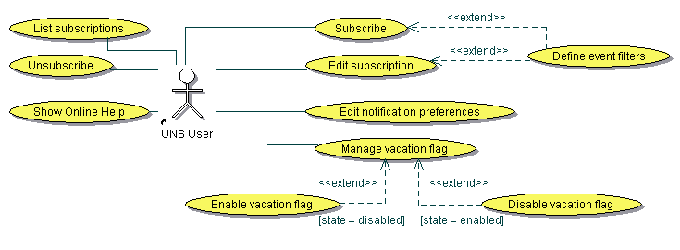

Figure 9 - REPORTNET User features Use Case diagram

XML-RPC User features
The users who belong to the UNS XML-RPC User role will be able to access the UNS Web site as well as XML-RPC methods exposed through XML-RPC server (Note that Zope is a native XML-RPC server). The following list represents the functions exposed to the XML-RPC users through the UNS Web Site:
- Show channels.
This function will present all Push channels created by authenticated XML-RPC users.
- Create channel
Allows the creation of the channel through the UNS Web User Interface. After creation of the channel it will be automatically set to disabled state and will wait for a user of the Zope manager or UNS Administrator role to enable it for usage.
- Edit channel.
This function allows XML-RPC users to edit only the description of the their Push channels.
- Show online help.
Shoes to XML-RPC users Online Help System.

The following list represents functions exposed to the XML-RPC users through the UNS XML-RPC server:
- Create Channel
Allows the creation of the channel by calling appropriate XML-RPC server method. Similar to channel creation through Web User Interface after creation the channel will be automatically set to disabled state and will wait for a user of the Zope manager or UNS Administrator role to enable it for usage.
- Send notification.
This function allows sending of the events data by calling appropriate XML-RPC server method. Sending to disabled channels as well as to channels owned by other XML-RPC users is not allowed by the UNS.
- Check if user can be subscribed.
This function allows XML-RPC users to check if they can subscribe EIONET user to channel owned by them.
- Make subscription
Allows subscribing of the REPORTNET users by calling appropriate XML-RPC server method. XML-RPC users can subscribe only to their own channels.

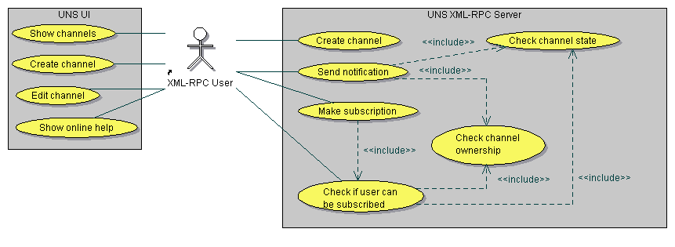

Figure 10 - XML-RPC User features Use Case diagram

Common features
These functions are common for all UNS users. Functional requirements related to these functions are described in section 3.2.3 of this document.
- Login. This feature will comprise of the following functions:
  - Authentication
  - Authorization
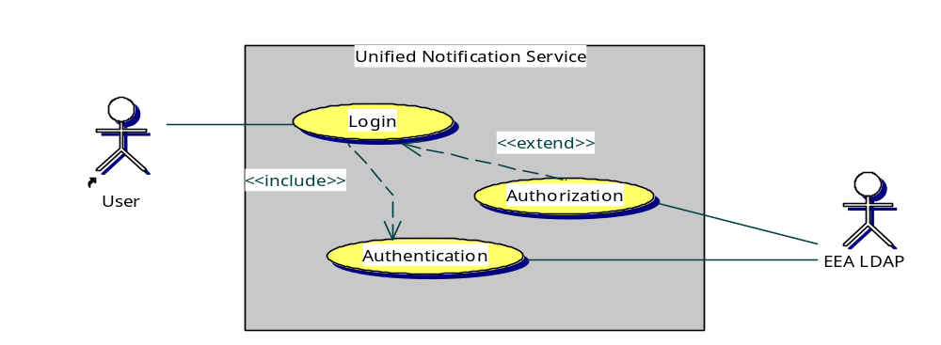

Figure 11 - Common features Use Case diagram

System features
These functions will be invoked by the system itself. . Functional requirements related to these functions are described in section 3.2.4 of this document.
- Run Havester.
Event harvesting is one of the essential UNS features. The following functions will be used during harvesting process:
  - Get expired channels.
Retrieves the list of all Pull channels that need to be harvested. Channel is expired when predefined refresh interval exceed.
  - Pull event data from the external services.
Retrieves events data from the external web service (external to the UNS) by invoking next functions:
    - Fetch data. Retrieves events content form the external web service.
    - Validate data. Validate form of the fetched data.
    - Transform data to RDF. If fetched events data are not in the RDF or RSS 1.0 form transforms it to RDF format (RSS 1.0 syntax).

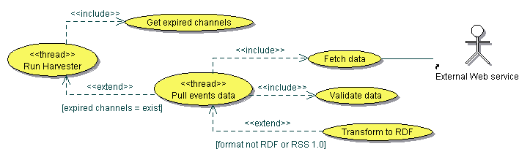

Figure 12 - Harvester features Use Case diagram

- Run notifications thread

Notifications functions will perform actually check of events data for which notification messages need to be generated. Generated messages will be sent to the REPORTNET users and appropriate events will be recorded in the service database. This function will invoke periodically next functions:
  - Check failed e-mail notifications.
Identifies failed e-mail notifications by communicating with the POP3 server.
  - Check vacation flags.
Checks if some of existing vacation flags need to be disabled automatically and in such case these flags are disabled.
  - Generate notifications.
Generate new notifications messages according to subscribed users and provided subscription filters.
  - Send notifications.
Sends new and failed e-mail notifications to subscribed users. The UNS will send notifications in four parallel threads, one foreach delivery type (Jabber, e-mail, WDB, RSS) as illustrated on the figure bellow.

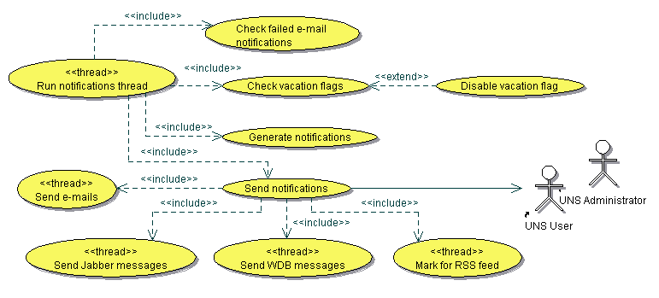

Figure 13 - Notifications trhead features Use Case diagram

User Classes and Characteristics
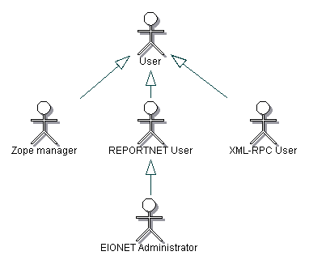

Figure 14 - User classes’ hierarchy Use case diagram

Anonymous User
An Anonymous User is any intranet/internet user who may access the UNS web site. These users will be able only to access the UNS welcome page and they will be able also to attempt login into the system.

Zope Manager
A Zope Manager complies with user who has the right to administer the Zope application server. This user needs to know all functional aspects of the UNS, as well as some technical characteristics and terminologies. He/she will have the privileges to execute all administrative functions of the UNS. The UNS does not allow Zope managers to make subscriptions to the event content channels and to create Push mode channels.

UNS User
A UNS User is a user reigtered in the EEA LDAP server who is allowed to subscribe/unsubscribe the desired type of events offered by some event channels. This user needs to have a clear understanding of the features offered by UNS to end users, as well as to understand available events he/she wants to subscribe to. This type of user will be notified from the UNS about events he/she subscribed to.

UNS Administrator
An UNS Administrator will be responsible for the administration of the UNS.
This user needs to know all functional aspects of the UNS, as well as some technical characteristics and terminologies. He/she will have the privileges to execute all administrative functions of the UNS except to create other users with EIONET Administrator role. UNS Administrators will be allowed also to make subscriptions to the event content channels. The UNS does not allow users of this role to create Push channels

XML-RPC User
An XML-RPC User can access UNS programmatically in order to create new PUSH channels or to push RDF formed data. This user is also able to see its own PUSH channels by using the UNS user interface as well to create new ones.

The following table summarises the availability of the UNS functions per UNS role.

Roles within the UNS environment
Function | Anonymous User | Zope Manager | UNS User | UNS Administrator | XML-RPC User
View UNS Website Welcome page | + | + | + | + | +
Request login | + | + | + | + | +
Create Pull channel |  | + |  | +
Edit Pull channel |  | + |  | +
Delete Pull channel |  | + |  | +
Create Push channel |  |  |  | +
Edit Pull channel |  | + |  | + | Only description
Delete Pull channel |  | + |  | +
Enable Push channel |  | + |  | +
Create notification template |  | + |  | +
Edit notification template |  | + |  | +
Delete notification template |  | + |  | +
Notifications throughput report |  | + |  | +
Failed notifications report |  | + |  | +
Delete problematic subscription |  | + |  | +
Show users list |  | + |  | XML-RPC users only
Add UNS Administrative users |  | +
Create XML-RPC Users |  | + |  | +
Change XML-RPC user password |  | + |  | +
Remove user |  | + |  | XML-RPC users only
Configure LDAP server |  | + |  | +
Configure Mail servers |  | + |  | +
Configure Database server |  | + |  | +
Configure Jabber server |  | + |  | +
Control Harvester thread |  | + |  | +
Control Notifications thread |  | + |  | +
Create subscription |  |  | + | +
Edit subscription |  |  | + | +
Delete subscription |  |  | + | +
Manage notification preferences |  |  | + | +
Enable/Disable vacation flag |  |  | + | +
View Online help |  | + | + | + | +
XML-RPC access  Create Push Channel |  |  |  |  | +
XML-RPC access  Send notification data |  |  |  |  | for channel owner
XML-RPC access  Check if specific user can be subscribed |  |  |  |  | for channel owner
XML-RPC access  Subscribe user |  |  |  |  | for channel owner

User Documentation
The Unified Notification Service will provide an online hierarchical and cross-linked help system in HTML that describes and illustrates all system functions. The Unified Notification Service will provide a complete user manual for end users and EIONET administrators. The delivery format will be MS Word.

Specific requirements
This section contains all of the UNS requirements at a level of detail sufficient to enable a system and system test case design which satisfies these requirements.

External Interface Requirements

User Interfaces
ID | REQ-3.1.1-1
Description | The UNS web client shall run on Microsoft Internet Explorer 5.5 or higher, Netscape Communicator 6.0 or higher and Opera 7.0 or higher.
Priority | High
Comments

ID | REQ-3.1.1-2
Description | The UNS UI shall automatically be presented in full screen for screen sizes of 800x600 pixels and up
Priority | High
Comments

ID | REQ-3.1.1-3
Description | The UNS user interfaces should be designed in accordance with good web design principles and the latest version of the EIONET design guidelines  (http://www.eionet.eu.int/software/).
Priority | High
Comments | EEA Design guidelines cover all design aspects of the UNS UI this section of the FSD should describe.

Hardware Interfaces
No hardware interfaces have been identified.

Software Interfaces

ID | REQ-3.1.3-1
Description | The UNS shall send event data as RDF to the Reportnet Web Dashboard system.
Priority | High
Comments | Other Agency web services and REPORTNET modules will be able to query the UNS for the harvested event/date data.

ID | REQ-3.1.3-2
Description | The UNS shall expose generated notifications as XML to other external applications.
Priority | High
Comments | UNS Users will be able to read their notificatios by using RSS reader software.

ID | REQ-3.1.3-3
Description | The UNS shall be able to harvest event data from other web services.
Priority | High
Comments

ID | REQ-3.1.3-4
Description | The UNS shall be able to interfere with the EEA LDAP server during the checking process of user credentials.
Priority | High
Comments

Communications Interfaces

ID | REQ-3.1.4-1
Description | The UNS services shall send notifications to subscribed users as e-mail messages by using the SMTP protocol.
Priority | High
Comments

ID | REQ-3.1.4-2
Description | The UNS services shall send notifications to subscribed users as Jabber messages by using XMPP.
Priority | High
Comments

ID | REQ-3.1.4-3
Description | The UNS services shall send notifications for subscribed users to the Reportnet Web Dashboards by using XML_RPC protocol.
Priority | High
Comments

ID | REQ-3.1.4-4
Description | Registered External web services shall be able to push event data to the UNS as XML by using the XML-RPC protocol.
Priority | High
Comments | Registered External Web service represents a system external to the UNS which has appropriate credentials to authenticate itself.

ID | REQ-3.1.4-5
Description | Registered External web services shall be able to subscribe the REPORTNET users by using the XML-RPC protocol.
Priority | High
Comments

ID | REQ-3.1.4-6
Description | Registered External web services shall be able to create their own push channels by using the XML-RPC protocol.
Priority | High
Comments

Functional requirements
Functional requirements define the fundamental actions that must take place in the REPORTNET Unified Notification Service in accepting and processing the inputs and in processing and generating the outputs. These fundamentals actions will include the following items:
- a brief introduction,
- a stimulus and response sequence,
- the associated requirements.
The set of these items represents the essential information to outline a specific Use Case as represented in section 2.2

Administrative features
This section is related to the UNS Administrative features which may be used by Zope Managers as well as by UNS Administrators. In the text bellow we will name Zope managers and UNS Administrators with the combined name “Administrative users”.

Manage Pull Event channels

Introduction/Purpose
An Administrative user whose identity has been verified shall have the option to access to the Pull event channels administration.

Stimulus/Response sequence
Stimulus: The administrator requests access to channels management
Response: UNS shows to the administrator the list of allowed operations and the list of existing event content channels

Associated Functional requirements
ID | REQ-3.2.1.1.3-1
Description | The UNS shall let an Administrative user who is logged into the system to access the content channels management section.
Priority | High
Comments

ID | REQ-3.2.1.1.3-2
Description | The UNS shall show to the Administrator a menu of allowed operations and a list of the existing content channels
Priority | High
Comments

Create content channel

Introduction/Purpose
An Administrative user whose identity has been verified shall have the option to add a new Pull content channel that will provide event data to the UNS.

Stimulus/Response sequence
Stimulus: The administrator requests to add a new content channel
Response: The UNS queries the administrator for relevant channel details
Stimulus: The administrator requests to save new channel details
Response: The UNS creates a new content channel
Stimulus: The administrator requests to define metadata elements for filtering
Response: The UNS shows list of retrieved metadata elements
Stimulus: The administrator selects desired metadata elements and saves new channel.
Response: The UNS creates new content channel

Associated Functional requirements
ID | REQ-3.2.1.2.3-1
Description | The UNS shall let an Administrator who is logged into the system to add a new Pull event content channel.
Priority | High
Comments

ID | REQ-3.2.1.2.3-2
Description | The UNS shall prompt the Administrator for the following details:  - Desired name of the new content channel  - Description of the content cannel  - Pull details:  - External provider URL  - Refresh delay for channel (time needed to pass between two harvest of the channel )  - Select Notification template from list of the existing ones that will be used generating notification messages.  - Allowed delivery types for a channel. Will be defined by selecting desired one from the list of the existing ones. While subscribing them, UNS Users will be able to choose desired delivery type from the list of the allowed delivery types.  - Access restriction. Will be defined by selecting desired EEA roles from the list of the existing one.
Priority | High
Comments

ID | REQ-3.2.1.2.3-3
Description | The UNS shall test the connection to the external resource before saving the relevant configuration
Priority | High
Comments

ID | REQ-3.2.1.2.3-4
Description | The UNS shall allow an Administrator to choose if he/her wants to define allowed filter metadata elements or to save the channel without defining filter elements.
Priority | High
Comments

ID | REQ-3.2.1.2.3-5
Description | The UNS shall inform an Administrator about the success or failure of the create operation with an appropriate message.
Priority | High
Comments

Edit content channel

Introduction/Purpose
An Administrator whose identity has been verified shall have the option to edit an existing content channel.

Stimulus/Response sequence
Stimulus: The administrator requests to edit an existing content channel.
Response: The UNS presents to the administrator existing channel details
Stimulus: The administrator requests to submit new channel details
Response: The UNS updates content channel

Associated Functional requirements
ID | REQ-3.2.1.3.3-1
Description | The UNS shall let an Administrator who is logged into the system to edit an existing event content channel.
Priority | High
Comments

ID | REQ-3.2.1.3.3-2
Description | The UNS shall allow the Administrator to change the following detailed parameters:  - Desired name of the new content channel. Current channel name will be offered by default.  - Description of the content cannel. Current channel description will be offered by default.  - Pull details:  - External provider URL. Current URL will be offered by default.  - Refresh delay for channel (time needed to pass between two harvest of the channel). Current value will be offered by default.  - Notification template. Select from list of the existing ones. Currently used will be selected by default.  - Allowed delivery types for a channel. Will be redefined by selecting/deselecting from the list of the existing ones. Currently used will be selected by default.  - Access restriction. Will be defined by selecting/deselecting desired EEA roles from the list of the existing ones. Currently used will be selected by default.
Priority | High
Comments

ID | REQ-3.2.1.3.3-3
Description | The UNS shall send appropriate e-mail notifications to the subscribed users to updated channel in case of restricting channel access privileges.
Priority | High
Comments

ID | REQ-3.2.1.3.3-4
Description | The UNS shall test the connection to the external resource before saving the relevant configuration.
Priority | High
Comments

ID | REQ-3.2.1.3.3-5
Description | The UNS shall allow an Administrator to update filter metadata elements or to update the channel without redefining filter elements.
Priority | High
Comments

ID | REQ-3.2.1.3.3-6
Description | The UNS shall inform an Administrator about the success or failure of the update operation with an appropriate message.
Priority | High
Comments

Remove content channel

Introduction/Purpose
An Administrator whose identity has been verified shall have the option to remove an existing content channel.

Stimulus/Response sequence
Stimulus: The administrator requests to remove an existing content channel.
Response: The UNS asks administrator to confirm removal
Stimulus: The administrator confirms removal
Response: The UNS deletes content channel and sends an e-mail notifications to subscribed users.

Associated Functional requirements
ID | REQ-3.2.1.4.3-1
Description | The UNS shall let an Administrator who is logged into the system to remove an existing Pull event content channel.
Priority | High
Comments

ID | REQ-3.2.1.4.3-2
Description | The UNS shall ask the Administrator to confirm removal of the channel.
Priority | High
Comments

ID | REQ-3.2.1.4.3-3
Description | The UNS shall remove all subscriptions made to this channel and send appropriate e-mail notifications to subscribed users.
Priority | High
Comments

ID | REQ-3.2.1.4.3-4
Description | The UNS shall inform an EIONET Administrator about the success or failure of the channel removal with an appropriate message.
Priority | High
Comments

Manage Push Event channels

Introduction/Purpose
An Administrative user whose identity has been verified shall have the option to access to the Push event channels administration.

Stimulus/Response sequence

Stimulus: The administrator requests access to channels management
Response: UNS shows to the administrator the list of allowed operations and the list of existing Push event content channels

Associated Functional requirements
ID | REQ-3.2.1.5.3-1
Description | The UNS shall let an Administrative user who is logged into the system to access the content channels management section.
Priority | High
Comments

ID | REQ-3.2.1.5.3-2
Description | The UNS shall show to the Administrator a menu of allowed operations and a list of the existing content channels
Priority | High
Comments

Edit content channel

Introduction/Purpose
An Administrator whose identity has been verified shall have the option to edit an existing Push content channel.

Stimulus/Response sequence

Stimulus: The administrator requests to edit an existing content channel.
Response: The UNS presents to the administrator existing channel details
Stimulus: The administrator requests to submit new channel details
Response: The UNS updates content channel

Associated Functional requirements
ID | REQ-3.2.1.6.3-1
Description | The UNS shall let an Administrator who is logged into the system to edit an existing Push event content channel.
Priority | High
Comments

ID | REQ-3.2.1.6.3-2
Description | The UNS shall allow the Administrator to change the following detailed paramters:  - Desired name of the new content channel. Current channel name will be offered by default.  - Description of the content cannel. Current channel description will be offered by default.  - Notification template. Select from list of the existing ones. Currently used will be selected by default.  - Allowed delivery types for a channel. Will be redefined by selecting/deselecting from the list of the existing ones. Currently used will be selected by default.  - Access restriction. Will be defined by selecting/deselecting desired EEA roles from the list of the existing ones. Currently used will be selected by default.
Priority | High
Comments

ID | REQ-3.2.1.6.3-3
Description | The UNS shall send appropriate e-mail notifications to the subscribed users to updated channel in case of restricting channel access privileges.
Priority | High
Comments

ID | REQ-3.2.1.6.3-4
Description | The UNS shall allow an Administrator to redefine filter metadata elements or to update the channel without redefining filter elements.
Priority | High
Comments

ID | REQ-3.2.1.6.3-5
Description | The UNS shall inform an Administrator about the success or failure of the update operation with an appropriate message.
Priority | High
Comments

Remove content channel

Introduction/Purpose
An Administrator whose identity has been verified shall have the option to remove an existing Push content channel.

Stimulus/Response sequence

Stimulus: The administrator requests to remove an existing content channel.
Response: The UNS asks administrator to confirm removal
Stimulus: The administrator confirms removal
Response: The UNS deletes content channel and sends an e-mail notifications to subscribed users.

Associated Functional requirements
ID | REQ-3.2.1.7.3-1
Description | The UNS shall let an Administrator who is logged into the system to remove an existing Push events content channel.
Priority | High
Comments

ID | REQ-3.2.1.7.3-2
Description | The UNS shall ask the Administrator to confirm removal of the channel.
Priority | High
Comments

ID | REQ-3.2.1.7.3-3
Description | The UNS shall remove all subscriptions made to this channel and send appropriate e-mail notifications to subscribed users.
Priority | High
Comments

ID | REQ-3.2.1.7.3-4
Description | The UNS shall inform an EIONET Administrator about the success or failure of the channel removal with an appropriate message.
Priority | High
Comments

Management of the Notifications templates

Introduction/Purpose
An Administrator whose identity has been verified shall have the option to access the notifications templates management section of the Administrative UI.

Stimulus/Response sequence
Stimulus: The administrator requests access to the notifications templates
Management
Response: The UNS shows the administrator the list of allowed operations and the list of existing notifications templates.

Associated Functional requirements
ID | REQ-3.2.1.8.3-1
Description | The UNS shall let an Administrator who is logged into the system to access the notifications management UI
Priority | High
Comments

ID | REQ-3.2.1.8.3-2
Description | The UNS shall show the Administrator the menu of  allowed UI operations:  - Add notification template  - Edit notification template  - Remove notification template
Priority | High
Comments

ID | REQ-3.2.1.8.3-3
Description | The UNS shall offer to the Administrator the menu of “Remove notification template” option for system default templates created during the UNS installation.
Priority | High
Comments

Create notification template

Introduction/Purpose
An Administrator whose identity has been verified shall have the option to define a new notification message template

Stimulus/Response sequence
Stimulus: The administrator requests to add a new notification template
Response: The UNS queries the administrator to enter the desired plain text and HTML template data.
Stimulus: The administrator submits the entered data
Response: The UNS saves a new notification profile and appends it to the list of existing ones

Associated Functional requirements
ID | REQ-3.2.1.9.3-1
Description | The UNS shall let an administrator who is logged into the system to create a new notification template.
Priority | High
Comments

ID | REQ-3.2.1.9.3-2
Description | The UNS shall prompt an Administrator for the following template details:  - Template name  - Template Subject  - Plain text template body  - HTML template body
Priority | High
Comments

ID | REQ-3.2.1.9.3-3
Description | The UNS shall support the use of placeholders inside templates text. Placeholders will be defined to support elementary information that the UNS holds.
Priority | High
Comments | The following list represents the placeholder that will be supported:  - $USER Full name of the user subscribed to receive notifications.  - $EVENT Harvested Event (with all its data)  - $EVENT.TITLE Title of the received event $EVENT.DATE Datetime when the Unified notification service received event  - $EVENT.CHANNEL Name of the channels used for harvesting event  - $UNSUSCRIBE_LINK Link that user may use to unsubscribe from channel

ID | REQ-3.2.1.9.3-4
Description | The UNS shall offer to the Administrator of the WYSIWYG editor editing the HTML template variant.
Priority | High
Comments

ID | REQ-3.2.1.9.3-5
Description | The UNS shall not allow an Administrator to save new template in case that both template variants are not provided (plain text and HTML).
Priority | High
Comments

ID | REQ-3.2.1.9.3-6
Description | The UNS shall inform an EIONET administrator about the operation success or failure
Priority | High
Comments

Edit notification template

Introduction/Purpose
An Administrator whose identity has been verified shall have the option to edit an existing notification template

Stimulus/Response sequence
Stimulus: The administrator requests to edit a notification template
Response: The UNS presents to the user the existing template data for the selected notification template
Stimulus: The administrator submits the changed data
Response: The UNS saves the changed notification template

Associated Functional requirements
ID | REQ-3.2.1.10.3-1
Description | The UNS shall let an Administrator who is logged into the system to edit an existing notification template.
Priority | High
Comments

ID | REQ-3.2.1.10.3-2
Description | The UNS shall allow Administrator to change the following details:  - Template name  - Template Subject  - Plain text template body  - HTML template body
Priority | High
Comments

ID | REQ-3.2.1.10.3-3
Description | The UNS shall not allow an Administrator to save new template in case that both templates variants are not provided (plain text and HTML).
Priority | High
Comments

ID | REQ-3.2.1.10.3-4
Description | The UNS shall inform an Administrator about the operation success or failure
Priority | High
Comments

Remove notification template

Introduction/Purpose
An Administrator whose identity has been verified shall have the option to remove an existing notification template

Stimulus/Response sequence
Stimulus: The administrator requests to remove a notification template
Response: The UNS checks if the submitted template is in use by any events content channel.. If not the UNS removes the template, otherwise it does not allow the operation and informs the user about this.

Associated Functional requirements
ID | REQ-3.2.1.11.3-1
Description | The UNS shall let an Administrator who is logged into the system to remove an existing notification template.
Priority | High
Comments

ID | REQ-3.2.1.11.3-2
Description | The UNS shall not allow an Administrator to remove a notification template in case it is in use by some events content channel.
Priority | High
Comments

ID | REQ-3.2.1.11.3-3
Description | The UNS shall inform an Administrator about the operation success or failure
Priority | High
Comments

Reports

Introduction/Purpose
An Administrator whose identity has been verified shall have the option to access to the UNS Reports section of the administrative UI.

Stimulus/Response sequence
Stimulus: The administrator requests access to the data Reports section
Response: The UNS shows to the administrator the list of all allowed operations.

Associated Functional Requirements
ID | REQ-3.2.1.12.3-1
Description | The UNS shall let an Administrator who is logged into the system to access Reports section of the UI.
Priority | High
Comments

ID | REQ-3.2.1.12.3-2
Description | The UNS shall show the Administrator a menu with the following operations:  - Notifications throughput report  - Failed Notifications report  - Remove problematic subscription
Priority | High
Comments | Removal of problematic subscriptions will be carried out directly from the Failed Notification report page.

Notifications throughput report

Introduction/Purpose
An Administrator whose identity has been verified shall have the option to request a notifications throughput report.

Stimulus/Response sequence
Stimulus: The administrator requests a notifications throughput report
Response: The UNS queries the administrator for data selection criteria.
Stimulus: The administrator submits the selection criteria to the UNS
Response: The UNS generates the report and presents it to the administrator

Associated Functional Requirements
ID | REQ-3.2.1.13.3-1
Description | The UNS shall let an Administrator who is logged into the system to generate a notifications throughput report.
Priority | High
Comments

ID | REQ-3.2.1.13.3-2
Description | The UNS shall prompt an Administrator for the report selection criteria consisting of the following details:  - Date/Time period  - Channel. Should be selected from the list of the existing channels. List will contain “All channels” option.  - User could select one or all of existing users from the list.
Priority | High
Comments

ID | REQ-3.2.1.13.3-3
Description | The UNS shall generate the report containing the following details:  - Total number of delivered notifications / failed notification deliveries.  - Daily summary including the number of notifications per delivery type, in form all/failed.
Priority | High
Comments

Failed notifications report

Introduction/Purpose
An Administrator whose identity has been verified shall have the option to request to see all failed notifications grouped by REPORTNET user

Stimulus/Response sequence
Stimulus: The administrator requests the failed notifications report
Response: The UNS shows the list of failed notifications to the administrator

Associated Functional Requirements
ID | REQ-3.2.1.14.3-1
Description | The UNS shall let an Administrator who is logged into the system to generate the failed notification list report.
Priority | High
Comments | Note that failed notifications can be identified only for e-mail and WDB delivery types.

ID | REQ-3.2.1.14.3-2
Description | The UNS shall generate the report containing failed notifications grouped by UNS user showing the following details:  - Username  - Subscribed channel  - Delivery type  - Number of failed  - Delivery address
Priority | High
Comments

Remove problematic subscription

Introduction/Purpose
An Administrator whose identity has been verified shall have the option to request to remove some problematic subscriptions.

Stimulus/Response sequence
Stimulus: The administrator requests to remove problematic subscriptions.
Response: The UNS deletes all the subscriptions together with notifications generated for the specific user

Associated Functional Requirements
ID | REQ-3.2.1.15.3-1
Description | The UNS shall let an Administrator who is logged into the system to remove the desired problematic subscriptions.
Priority | High
Comments

ID | REQ-3.2.1.15.3-2
Description | The UNS shall ask an Administrator to confirm subscription removal.
Priority | High
Comments

ID | REQ-3.2.1.15.3-3
Description | The UNS shall inform an EIONET administrator about the operation success or failure
Priority | High
Comments

Edit Application configuration parameters

Introduction/Purpose
An Administrator whose identity has been verified shall have the option to edit the UNS configuration parameters.

Stimulus/Response sequence
Stimulus: The administrator requests to edit the UNS configuration parameters.
Response: The UNS shows the list of configuration items and queries the administrator to enter details.

Associated Functional Requirements
ID | REQ-3.2.1.18.3-1
Description | The UNS shall let an Administrator who is logged into the system to configure the UNS application
Priority | High
Comments

ID | REQ-3.2.1.18.3-2
Description | The UNS shall allow editing of the following configuration parameters:  - Mail server access parameters  - SMTP server access parameters  - POP3 server access parameters  - Database server access parameters  - LDAP server access parameters  - Jabber server access parameters  - Time interval for pulling events data  - Start/stop for Harvester daemon process  - Time interval for generation of notifications  - Start/stop for Notifications generation daemon process
Priority | High
Comments

ID | REQ-3.2.1.18.3-3
Description | The UNS shall validate and test the new configuration before saving it
Priority | High
Comments

ID | REQ-3.2.1.18.3-4
Description | The UNS shall not allow saving of not valid configuration parameters.
Priority | High
Comments

ID | REQ-3.2.1.18.3-5
Description | The UNS shall not allow changing of the SMTP and/or the Jabber configuration if Notifications daemon is running.
Priority | High
Comments

ID | REQ-3.2.1.18.3-6
Description | The UNS shall not allow changing of the Database configuration if any of the UNS daemon is running (Harvester daemon or Notifications daemon)
Priority | High
Comments

ID | REQ-3.2.1.18.3-7
Description | The UNS shall inform an Administrator about the operation success or failure.
Priority | High
Comments

Manage Users

Introduction/Purpose
An Administrator whose identity has been verified shall have the option to access the users management section of the Administrative UI.

Stimulus/Response sequence

Stimulus: The administrator requests access to the users management.
Response: The UNS shows the administrator the list of allowed operations and the list of existing users.

Associated Functional requirements
ID | REQ-3.2.1.17.3-1
Description | The UNS shall let an Administrator who is logged into the system to access the users management UI
Priority | High
Comments

ID | REQ-3.2.1.17.3-2
Description | The UNS shall show to the Administrator the list of the existing users while accessing to User management section of the UI as follows:  - List containing UNS Administrators and XML-RPC users should be presented if and only if an Administrator with Zope manager role has accessed the user management.  - List containing XML-RPC users should be presented for Administrators of the UNS Administrators role.
Priority | High
Comments

ID | REQ-3.2.1.17.3-3
Description | The UNS shall inform an Administrator about success or failure of the operation.
Priority | High
Comments

Add UNS Administrator

Introduction/Purpose
A Zope manager (Administrator with the Zope manager role) whose identity has been verified shall have the option to add new UNS Administrative users.

Stimulus/Response sequence
Stimulus: The Zope manager requests to add a new user of the UNS Administrator role.
Response: The UNS queries the administrator to enter new user username.
Stimulus: The administrator submits the entered data
Response: The UNS checks the existence of the new user in EEA LDAP and add the new user to the UNS environment.

Associated Functional requirements
ID | REQ-3.2.1.18.3-1
Description | The UNS shall let a Zope manager who is logged into the system to add a new user of the UNS Administrator role.
Priority | High
Comments

ID | REQ-3.2.1.18.3-2
Description | The UNS shall prompt a Zope manager for the user’s username.
Priority | High
Comments

ID | REQ-3.2.1.18.3-3
Description | The UNS shall not allow adding of the new UNS Administartors in the following circumstances:  - User with provided username does not exists in the EEA LDAP  - Other user with same username already exists within the UNS environment
Priority | High
Comments

ID | REQ-3.2.1.18.3-4
Description | The UNS shall inform a Zope manager about success or failure of the operation.
Priority | High
Comments

Create XML-RPC User

Introduction/Purpose
An Administrator whose identity has been verified shall have the option to create a new user of the XML-RPC role.

Stimulus/Response sequence

Stimulus: An Administrator requests to create a new XML-RPC user.
Response: The UNS queries the administrator to enter the desired username and password for new user.
Stimulus: The administrator submits the entered data
Response: The UNS creates a new XML-RPC user.

Associated Functional requirements
ID | REQ-3.2.1.19.3-1
Description | The UNS shall let an administrator who is logged into the system to create a new notification template.
Priority | High
Comments

ID | REQ-3.2.1.19.3-2
Description | The UNS shall prompt an Administrator for the following user details:  - Username  - Password  - Password confirmation
Priority | High
Comments

ID | REQ-3.2.1.19.3-3
Description | The UNS shall not allow adding a the new XML-RPC user in the following circumstances:  - User with provided username already exists in the EEA LDAP  - Other user with same username already exists within the UNS environment  - Provided password contains other characters than ASCII.  - Provided password does not mach with password confirmation.
Priority | High
Comments

ID | REQ-3.2.1.19.3-4
Description | The UNS shall inform an Administrator about success or failure of the operation.
Priority | High
Comments

Change XML-RPC User password

Introduction/Purpose
An Administrator whose identity has been verified shall have the option to change the password of an existing XML-RPC user.

Stimulus/Response sequence

Stimulus: An Administrator requests to change user’s password
Response: The UNS queries an Administartor to enter new password.
Stimulus: The administrator submits new data
Response: The UNS saves the changed user profile.

Associated Functional requirements
ID | REQ-3.2.1.20.3-1
Description | The UNS shall let an Administrator who is logged into the system to change password of an existing XML-RPC user.
Priority | High
Comments

ID | REQ-3.2.1.20.3-2
Description | The UNS shall prompt an Administrator to enter new password as well as to confirm it.
Priority | High
Comments

ID | REQ-3.2.1.20.3-3
Description | The UNS shall not allow saving of the new XML-RPC user password in the following circumstances:  - Provided password contain other characters than ASCII.  - Provided password does not mach with password confirmation.
Priority | High
Comments

ID | REQ-3.2.1.20.3-4
Description | The UNS shall inform Administrator about the operation success or failure
Priority | High
Comments

Remove user

Introduction/Purpose
An Administrator whose identity has been verified shall have the option to remove an existing user from the UNS environment.

Stimulus/Response sequence

Stimulus: An Administrator requests to remove an existing user.
Response: The UNS removes user.

Associated Functional requirements
ID | REQ-3.2.1.21.3-1
Description | The UNS shall let an Administrator who is logged into the system to remove an existing user.
Priority | High
Comments

ID | REQ-3.2.1.21.3-2
Description | The UNS shall allow removing user as the follows:  - Zope manager can remove UNS Administrators as well as XML-RPC users.  - UNS Administrator can remove only XML-RPC users.
Priority | High
Comments

ID | REQ-3.2.1.21.3-3
Description | The UNS shall inform an Administrator about success or failure of the operation.
Priority | High
Comments

UNS User
UNS User features are allowed to all EEA registered users. More precisely within UNS user classes hierarchy those features are allowed to all user classes that inherits UNS User class.

Subscribe

Introduction/Purpose
An UNS user whose identity has been verified shall have the option to subscribe him/her to the desired content channel.

Stimulus/Response sequence
Stimulus: An UNS User requests to subscribe to the desired event content channel
Response: The UNS shows the user the list of available channels and queries the user to select the desired channel and to enter the notification details.
Stimulus: The User requests to submit new subscription details
Response: The UNS creates a new subscription for the identified user and returns to the user the list of existing subscriptions.
Stimulus: A UNS User requests to cancel the subscription process
Response: The UNS returns to the user the list of his/her existing subscriptions.

Associated Functional requirements
ID | REQ-3.2.2.1.3-1
Description | The UNS shall allow an UNS User who is logged into the system to subscribe him/herself to the desired channel.
Priority | High
Comments

ID | REQ-3.2.2.1.3-2
Description | The UNS shall prompt a UNS User for the following details:  - Desired Notification delivery type. (e-mail, jabber, web dashboards, RSS). User will be able to choose between delivery types that are allowed for Notification profile type of desired channel  - Jabber address if and only if has not been provided already  - Web dashboards address if and only if has not been provided already
Priority | High
Comments | The User will be able to select only channels allowed to his/her role

ID | REQ-3.2.2.1.3-3
Description | The UNS shall allow an UNS user to define filters that will instruct the UNS what notifications shall be sent for events provided by subscribed channel.
Priority | High
Comments | See more details in the Section 3.2.2.4

ID | REQ-3.2.2.1.3-4
Description | The UNS shall store all data in the service database and make these data available to the notification daemon.
Priority | High
Comments

ID | REQ-3.2.2.1.3-5
Description | The UNS shall inform the user about the success or failure of the subscribe operation with an appropriate message.
Priority | High
Comments

Unsubscribe

Introduction/Purpose
An UNS user whose identity has been verified shall have the option to remove his/her existing subscription.

Stimulus/Response sequence
Stimulus: An UNS User requests to unsubscribe for the event content channel
Response: The UNS checks if sending of notifications is in progress. If not UNS unsubscribe the user otherwise it shows the user an appropriate message.

Associated Functional requirements
ID | REQ-3.2.2.2.3-1
Description | The UNS shall allow a UNS User who is logged into the system to unsubscribe him/herself from the event channel.
Priority | High
Comments

ID | REQ-3.2.2.2.3-2
Description | The UNS shall inform the user about the success or failure of the unsubscribe operation with the appropriate message.
Priority | High
Comments

ID | REQ-3.2.2.2.3-3
Description | The UNS shall not allow the unsubscribe action if sending of notifications is in progress.
Priority | High
Comments

Edit subscription

Introduction/Purpose
An UNS user whose identity has been verified shall have the option to edit an existing subscription.

Stimulus/Response sequence
Stimulus: An UNS User selects a subscription from the list of existing ones and requests to edit it.
Response: The UNS checks if sending of notifications is in progress. If not it shows the user the subscription details, otherwise it shows the user the appropriate message
Stimulus: An UNS User edits allowed data and submits
Response: The UNS checks if sending of notifications is in progress. If not the UNS saves the new data and returns the user the list of existing notifications, otherwise it shows the user the appropriate message and leaves the user on the subscription details page.
Stimulus: An UNS User requests to cancel the edit process
Response: The UNS returns the user to the list of existing subscriptions.

Associated Functional requirements
ID | REQ-3.2.2.3.3-1
Description | The UNS shall let an UNS User who is logged into the system to edit an existing subscription
Priority | High
Comments

ID | REQ-3.2.2.3.3-2
Description | The UNS shall not allow this action if sending of notifications is in progress.
Priority | High
Comments

ID | REQ-3.2.2.2.3-3
Description | The UNS shall allow the user to modify the following details  - Notification delivery type (E-mail, jabber, web dashboards, RSS).  - Jabber address if and only if has not been provided already  Web dashboards address if and only if has not been provided already
Priority | High
Comments

ID | REQ-3.2.2.1.3-4
Description | The UNS shall allow a UNS user to define events filters that will instruct the UNS what notifications shall be sent for events provided by subscribed channel.
Priority | High
Comments | Section 3.2.2.4

ID | REQ-3.2.2.3.3-5
Description | The UNS shall inform the user about the operation success or failure with the appropriate message.
Priority | High
Comments

ID | REQ-3.2.2.3.3-6
Description | The UNS shall allow the user to cancel the operation.
Priority | High
Comments

Define events filters

Introduction/Purpose
A UNS user whose identity has been verified shall have the option to define events filter that will instruct the UNS what notifications shall be sent for events provided by subscribed channel. If a user does not provide filters for a specific channel all events will be included while generating and sending notification messages.

Stimulus/Response sequence
Stimulus: An UNS User chooses to define events filters for an existing subscription or for the new one.
Response: The UNS presents to user filters management operations.
Stimulus: An UNS User defines his/her filters and submits request.
Response: The UNS saves user’s filters.

Associated Functional requirements
ID | REQ-3.2.2.4.3-1
Description | The UNS shall let a UNS User who is logged into the system to define his/her events filters.
Priority | High
Comments

ID | REQ-3.2.2.4.3-3
Description | Each events filter shall be built of one or more conditions.
Priority | High
Comments | Condition is expression in form: “META-DATA ELEMENT = VALUE”

ID | REQ-3.2.2.4.3-4
Description | The UNS shall not allow usage of the same condition more than once within same filter.
Priority | High
Comments

ID | REQ-3.2.2.4.3-5
Description | The UNS shall provide to a user the following operations on filter conditions:  - Add condition to a filter  - Remove condition from a filter
Priority | High
Comments

ID | REQ-3.2.2.4.3-5
Description | The UNS shall provide to a user the following operations on filters:  - Add filter  - Edit filter  - Remove filter
Priority | High
Comments

ID | REQ-3.2.2.4.3-6
Description | The UNS shall not allow creation of equal filters.
Priority | High
Comments | Filter is equal with another one if they consist of exactly the same statements.

ID | REQ-3.2.2.4.3-7
Description | The UNS shall worn the user with appropriate message if there are overlapped filters.
Priority | High
Comments | Filter is overlapped with another filter when the statements contained in one filter are superset of statements contained in another one.

Edit notification preferences

Introduction/Purpose
A UNS user whose identity has been verified shall have the option to edit his/her own notifications details.

Stimulus/Response sequence

Stimulus: A UNS User selects to edit his/her own preferences.
Response: The UNS presents to user his/her current preferences and allow editing of these preferences.
Stimulus: A UNS User edits his/her preferences and submits data.
Response: UNS saves new user’s preferences and shows information about the success of the operation.

Associated Functional requirements
ID | REQ-3.2.2.5.3-1
Description | The UNS shall let a UNS User who is logged into the system to edit his/her notification preferences.
Priority | High
Comments

ID | REQ-3.2.2.5.3-3
Description | The UNS shall allow the user to modify the following preferences:  - Jabber address  - Web dashboards address  - Preferred format of e-mail notification messages
Priority | High
Comments | E-mail address can not be changed since it is harvested from the EEA CIRCA system.

ID | REQ-3.2.2.5.3-4
Description | The UNS shall check jabber and WDB address format correctness before saves it.
Priority | High
Comments

ID | REQ-3.2.2.5.3-5
Description | The UNS shall inform the user about the operation success or failure with the appropriate message.
Priority | High
Comments

Manage vacation flag

Introduction/Purpose
A UNS user whose identity has been verified shall have the option to manage vacation flag. Vacation flag instructs UNS if the sending of notifications should be stopped for some period of time.

Stimulus/Response sequence

Stimulus: A UNS User requests to manage his/her own vacation flag.
Response: The UNS checks current state of the user’s vacation flag. If vacation flag is enabled already it shows to user option to disable it, otherwise it shows the user option to enable it.
Stimulus: A UNS User edits submits request to the UNS.
Response: The UNS enables or disablesthe vacation flag depending on the type of submitted request.

Associated Functional requirements
ID | REQ-3.2.2.6.3-1
Description | The UNS shall let an UNS User who is logged into the system to manage his/her own vacation flag.
Priority | High
Comments

ID | REQ-3.2.2.6.3-2
Description | The UNS shall show to a UNS User the appropriate vacation flag operation as follows:  - Enable vacation flag if and only if current state of the user’s vacation flag is “disabled”  - Disable vacation flag if and only if current state of the user’s vacation flag is “enabled”
Priority | High
Comments

ID | REQ-3.2.2.6.3-3
Description | If an UNS User wants to enable vacation flag the UNS shall provide the option for defining the date when vacation flag should be automatically disabled by the UNS. Providing this date shall be optional.
Priority | High
Comments | If user does not provide date for the automatic disabling of a vacation flag, it will stay enabled until the user disables it manually.

ID | REQ-3.2.2.6.2-4
Description | The UNS shall inform the user about success or failure of the operation with the appropriate message.
Priority | High
Comments

XML-RPC User
XML-RPC User features are related to all users that belong to the UNS XML-RPC role users.

Create channel (By using the UNS Web User Interface)

Introduction/Purpose
An XML-RPC user whose identity has been verified shall have the option to create new Push events content channels by using the UNS Web User Interface.

Stimulus/Response sequence

Stimulus: An XML-RPC user requests to add a new content channel
Response: The UNS queries the administrator for relevant channel details
Stimulus: An XML-RPC user requests to save the new channel details
Response: The UNS creates a new content channel

Associated Functional requirements
ID | REQ-3.2.3.1.3-1
Description | The UNS shall let an XML-RPC User who is logged into the system to create a new Push event content channel.
Priority | High
Comments

ID | REQ-3.2.3.1.3-2
Description | The UNS shall prompt for the following details:  - Desired name of the new content channel  - Description of the content cannel
Priority | High
Comments

ID | REQ-3.2.3.1.3-3
Description | The UNS shall inform an XML-RPC user about the success or failure of the create operation with an appropriate message.
Priority | High
Comments

Create channel (By using calling XML-RPC method)

Introduction/Purpose
An XML-RPC user whose identity has been verified shall have the option to create new Push channel by calling the appropriate UNS XML-RPC method.

Stimulus/Response sequence

Stimulus: An XML-RPC user calls the UNS XML-RPC method.
Response: The UNS creates new Push channel.

Associated Functional requirements
ID | REQ-3.2.3.1.3-1
Description | The UNS shall let an authenticated XML-RPC user to create new Push channels.
Priority | High
Comments

ID | REQ-3.2.3.1.3-2
Description | An XML-RPC user shall provide the following details while calling XML-RPC method:  - Desired name of the new content channel  - Description of the content cannel
Priority | High
Comments

ID | REQ-3.2.3.1.3-3
Description | The default new channel state within the UNS shall be “Disabled”
Priority | High
Comments

Edit channel

Introduction/Purpose
An XML-RPC user whose identity has been verified shall have the option to edit the description of an existing content channel by using the UNS Web User Interface.

Stimulus/Response sequence

Stimulus: An XML-RPC user requests to edit an existing content channel.
Response: The UNS presents to the XML-RPC user the existing channel details
Stimulus: An XML-RPC user requests to submit new channel description
Response: The UNS updates content channel

Associated Functional requirements
ID | REQ-3.2.3.3.3-1
Description | The UNS shall let an XML-RPC user who is logged into the system to edit an existing event content channel.
Priority | High
Comments

ID | REQ-3.2.3.3.3-2
Description | The UNS shall allow an XML-RPC user to change the following details:  - Description of the content cannel. Current channel description will be offered by default.
Priority | High
Comments

ID | REQ-3.2.3.3.3-3
Description | The UNS shall inform an XML-RPC user about the success or failure of the update operation with an appropriate message.
Priority | High
Comments

Send notification

Introduction/Purpose
An XML-RPC user whose identity has been verified shall have the option to send notifications by using his/her own channels by calling the appropriate UNS XML-RPC method.

Stimulus/Response sequence

Stimulus: An XML-RPC user calls the UNS XML-RPC method.
Response: The UNS processes and sends the events data.

Associated Functional requirements
ID | REQ-3.2.3.4.3-1
Description | The UNS shall let an authenticated XML-RPC user to send events data by using the specified Push channel.
Priority | High
Comments

ID | REQ-3.2.3.4.3-2
Description | The UNS shall not allow an XML-RPC user to send events data by using channels that belong to other XML-RPC users.
Priority | High
Comments

ID | REQ-3.2.3.4.3-3
Description | The UNS shall not allow an XML-RPC user to send events data by using disabled channels.
Priority | High
Comments

ID | REQ-3.2.3.4.3-4
Description | An XML-RPC user shall provide the following details while calling XML-RPC method:  - Unique identifier of the Push channel in the UNS.  - Events data as straightforward RDF triples in a list-of-lists structure OR events data as RDF formed string.
Priority | High
Comments

ID | REQ-3.2.3.4.3-5
Description | All different metadata elements identified by the UNS shall be automatically allowed for events filter creation.
Priority | High
Comments

Check if user can be subscribed

Introduction/Purpose
An XML-RPC user whose identity has been verified shall have the option to check if the specific Reportnet user can be subscribed to specified channel by calling the appropriate UNS XML-RPC method.

Stimulus/Response sequence

Stimulus: An XML-RPC user calls the UNS XML-RPC method.
Response: The UNS proecesses the request and returns a Boolean value indicating if the subscription can be completed.

Associated Functional requirements
ID | REQ-3.2.3.5.3-1
Description | The UNS shall let an authenticated XML-RPC user to make subscription for a specific Reportnet user on specified Push channel.
Priority | High
Comments

ID | REQ-3.2.3.5.3-2
Description | The UNS shall not allow an XML-RPC user to perform this operation on channels that belong to other XML-RPC users.
Priority | High
Comments

ID | REQ-3.2.3.5.3-3
Description | The UNS shall not allow an XML-RPC user to perform this operation on disabled channels.
Priority | High
Comments

ID | REQ-3.2.3.5.3-4
Description | An XML-RPC user shall provide the following details while calling XML-RPC method:  - Unique identifier of the Push channel in the UNS.  - EEA's LDAP (Synchronized with CIRCA) user’s username.  - An array of the dictionaries in form RDF predicate-object representing user’s filters.
Priority | High
Comments

ID | REQ-3.2.3.5.3-5
Description | The UNS shall process the subscription request as follows:  - If the specified user has been subscribed already to the specified channel the UNS shall update the existing subscription.  - If the specified user is not subscribed to the specified channel the UNS shall create new subscription with e-mail delivery type only.
Priority | High
Comments

Make subscription

Introduction/Purpose
An XML-RPC user whose identity has been verified shall have the option to make events subscription for the specified user and specified channel.

Stimulus/Response sequence

Stimulus: An XML-RPC user calls the UNS XML-RPC method.
Response: The UNS processes subscription request.

Associated Functional requirements
ID | REQ-3.2.3.6.3-1
Description | The UNS shall let an authenticated XML-RPC user to check if the specific Reportnet user can be subscribed on specified Push channel.
Priority | High
Comments

ID | REQ-3.2.3.6.3-2
Description | The UNS shall not allow an XML-RPC user to perform this check on channels that belong to other XML-RPC users.
Priority | High
Comments

ID | REQ-3.2.3.6.3-3
Description | The UNS shall not allow an XML-RPC user to perform this check on disabled channels.
Priority | High
Comments

ID | REQ-3.2.3.6.3-4
Description | AnXML-RPC user shall provide the following details while calling XML-RPC method:  - Unique identifier of the Push channel in the UNS.  - EEA's LDAP (Synchronized with CIRCA) user’s username.
Priority | High
Comments

Common features

Authentication/Authorization

Introduction/Purpose
Any user who wants access to the UNS functions needs to first authenticate him/her.

Stimulus/Response sequence
Stimulus: A User requests to login on the UNS.
Response: The UNS queries the User to enter a username and a password

Associated Functional requirements
ID | REQ-3.2.4.1.3-1
Description | The UNS shall authenticate a registered user.
Priority | High
Comments

ID | REQ-3.2.4.1.3-2
Description | In case of unsuccessful login,UNS shall keep a login dialog resembling to an error message that will inform the user about the inappropriate data provided.
Priority | High
Comments

ID | REQ-3.2.4.1.3-3
Description | In case of successful login,UNS shall perform authorization and will show the user to all features of the UNS User Interface allowed to his/her role
Priority | High
Comments

System features

Pull events data

Introduction/Purpose
UNS shall periodically harvest all data for event content channels working in PULL mode.

Stimulus/Response sequence
Stimulus: The System timer triggers Harvester thread.
Response: The UNS queries external systems for new event data.

Associated Functional requirements
ID | REQ-3.2.5.1.3-1
Description | The UNS shall be able to harvest events data data from external resources for event content channels working in PULL mode.
Priority | High
Comments

ID | REQ-3.2.5.1.3-2
Description | In one execution of the Harvester thread,UNS shall harvest events data only for channels where predefined channel refresh period has expired.
Priority | High
Comments

ID | REQ-3.2.5.1.3-3
Description | The UNS shall be capable to process the following forms of the data:  - RDF  - RSS (0.9.x, 1.0, 2.0).
Priority | High
Comments

ID | REQ-3.2.5.1.3-4
Description | The UNS shall parse and validate harvested data.
Priority | High
Comments

ID | REQ-3.2.5.1.3-5
Description | The UNS shall merge the harvested event data with the information which has been already harvested.
Priority | High
Comments | This refers to the UNS capability to make a distinction between new or changed events data and data that have been already harvested in order to avoid duplicate entries for the specific channel in the UNS database.

ID | REQ-3.2.5.1.3-6
Description | In case of errors the UNS shall record the error details into the system log in order to allow administrators the tracking of UNS daemons.
Priority | High
Comments

Run Notifications thread

Introduction/Purpose
The UNS will contain Notifications thread which will run periodically in order to invoke notifications related system functions.

Stimulus/Response sequence
Stimulus: The System timer triggers the Notifications thread.
Response: The UNS system checks existence of failed e-mail notifications, queries the service database in order to prepare, generate and send notifications.

Associated Functional requirements
ID | REQ-3.2.5.2.3-1
Description | One execution of the UNS Notifications thread shall perform the following activities:  - Identify failed e-mail messages.  - Disable vacation flags in case that disabling date has been reached.  - Generate notification messages for new events.  - Send notification messages to users.
Priority | High
Comments

ID | REQ-3.2.5.2.3-2
Description | The UNS shall query POP3 server in order to identify failed e-mail notifications.
Priority | High
Comments

ID | REQ-3.2.5.2.3-3
Description | The UNS shall include User defined filters while generating notification messages.
Priority | High
Comments

ID | REQ-3.2.5.2.3-4
Description | The UNS shall prevent successful sending of the same events more than once.
Priority | High
Comments

ID | REQ-3.2.5.2.3-5
Description | The UNS shall identify and record notification sending problems .
Priority | High
Comments

ID | REQ-3.2.5.2.3-6
Description | The UNS shall send the same events more than once in case of errors.
Priority | High
Comments | If sending of a notification failes, the UNS will retry it next execution of the Notifications thread.

ID | REQ-3.2.5.2.3-7
Description | The UNS shall take into account preferred message format specified by subscribed uses while sending e-mail notifications.
Priority | High
Comments

Nonfunctional requirements
Since the expectations of all different user groups of a software system like REPORTNET Unified Notification Service cannot only be specified by concrete functional requirements, the so-called non-functional requirements gain in importance especially with respect to the software quality.
Non-functional requirements are requirements, which are not specifically concerned with the functionality of a software system. Instead, non-functional requirements place restrictions on the product being developed and the development process, and they specify external constraints that the product must meet.
Many non-functional requirements relate to the system as a whole rather than to individual system features. This means that they are often more critical than individual functional requirements. While failure to meet an individual functional requirement may degrade the system, failure to meet a non-functional system requirement may make the whole system unusable.
The following sections provide the specific non-functional requirements that will be satisfied in the context of the UNS.

Software Quality Attributes

A software quality model, which is based on six main characteristics and their respective sub-characteristics, is outlined in the following figure:

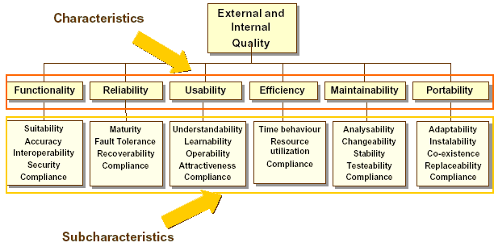

The detailed specification of the required software quality aspects for the REPORTNET Unified Notification Service will be mainly based on this model.

Functionality
Functionality of the Unified Notification Service is the capability to provide functions, which meet stated and implied needs when the software is used under specified conditions. More specifically, the following aspects need to be taken into account:
- Suitability/Completeness. The capability of the UNS product to provide an appropriate set of functions for specified tasks and user objectives.
- Accuracy/Correctness. The capability of the UNS to provide the right or agreed results or effects with the needed degree of precision
- Interoperability. The capability of the UNS to interact with one or more specified systems.
- Security. The capability of the UNS product to protect information and data so that unauthorized persons or systems cannot read or modify this information and authorized persons or systems are not denied access to this information.

ID | REQ-3.3.1.0-1
Description | The UNS shall be consistent with this functional specification.
Priority | High
Comments

ID | REQ-3.3.1.0-2
Description | The UNS should include a software integrity check and recovery
Priority | Medium
Comments | The contractor will provide script that shall be executed after installation of the Unified Notification Service. It will generate MD5 sum for each UNS file and save it in special (named it: sum file) file which will be stored on some secure place defined by the EEA. After some time the EIONET Administrator will be able to execute the script again that will compute MD5 sum for all files in application and check it against existing sum files for files integrity. If difference exists, the script will generate warning which file is corrupted.

ID | REQ-3.3.1.0-3
Description | In case of Pushing events data, UNS shall restrict access only to the registered services which shall authenticate themselves before Pushing data.
Priority | High
Comments

ID | REQ-3.3.1.0-4
Description | Access to the administration module of UNS shall be restricted only to EIONET administrators registered on the EEA LDAP.
Priority | High
Comments

ID | REQ-3.3.1.0-5
Description | Access to the users module of UNS shall be restricted only to REPORTNET users registered on the EEA LDAP.
Priority | High
Comments

Reliability

ID | REQ-3.3.1.1-1
Description | The UNS shall not corrupt or lose data.
Priority | High
Comments | This refers to the UNS system modules and their functions that will work with data. This excludes errors that may occur because of Operating system, Hardware, Database engine, Application server errors.

ID | REQ-3.3.1.1-2
Description | The UNS should work in a stable and responsive way with 30-50 concurrently logged in users accessing the system in accordance with the actions required by their user profile.
Priority | High
Comments | Appropriate Stress Tests will be developed and used to confirm that this has been achieved.

ID | REQ-3.3.1.1-3
Description | The UNS should recognise violations of syntactic conditions for input. In case the UNS recognises an input as erroneous or as undefined, it shall not process this as a permissible input.
Priority | High
Comments | This corresponds to the capability of the UNS to not allow user mistakes while they provide data through the UI.

ID | REQ-3.3.1.1-4 <TBD>
Description | The UNS should have a 98% up-time
Priority | High
Comments | Availability: The percentage of time that the software system is fully functional.  The Contractor understands that the Agency is pleased with the current configuration of hardware and the various monitoring and recovery mechanisms. It is understood that the Agency will undertake all necessary actions in terms of hardware, monitoring and recovery mechanisms that will allow a 98% up-time.

Usability

ID | REQ-3.3.1.2-1
Description | Ease of Overview. The UNS should provide information to the user in such a form that it is easily visible and easy to read. The user should be guided by appropriate coding and grouping of the information. Where necessary, the UNS should alert the user.
Priority | High
Comments | Effort will be made by the Contractor to meet this requirement. At the end of the evaluation and during the production support period the Contractor will spend an additional effort (up to the maximum allowed) to satisfy any comments that will be formally expressed by the Agency regarding this requirement.

ID | REQ-3.3.1.2-2
Description | Operability. The execution of functions that have serious consequences shall be reversible, or the UNS shall give a clear warning of the consequences and request information before executing the command. In particular, erasure and overwriting of data, as well as interruptions of a lengthy processing operation, have serious consequences
Priority | High
Comments | Effort will be made by the Contractor to meet this requirement. At the end of the evaluation and during the production support period the Contractor will spend an additional effort (up to the maximum allowed) to satisfy any comments that will be formally expressed by the Agency regarding this requirement.

Efficiency

ID | REQ-3.3.1.3-1
Description | The UNS shall support a notification through-put of 500 notification events per day
Priority | High
Comments

ID | REQ-3.3.1.3-2
Description | The UNS shall support around 1000 users with notification profiles
Priority | High
Comments

ID | REQ-3.3.1.3-3
Description | Response time for notifications to be issued following an event should be less than one working day
Priority | High
Comments

Maintainability

ID | REQ-3.3.1.4-1
Description | The UNS shall have a modular design to meet the functional features
Priority | High
Comments

ID | REQ-3.3.1.4-2
Description | Naming conventions should be applied to the development environment and the source code (e.g. expressive names for names for functions comprising prefixes from which the context can be derived).
Priority | High
Comments

ID | REQ-3.3.1.4-3
Description | For Python code the indentation is 4 spaces. No tabs are allowed in the code.
Priority | High
Comments

Portability

ID | REQ-3.3.1.5-1
Description | The UNS modules shall operate under any distribution/version of Linux where the Operating environment described in 2.1.3 can be installed
Priority | High
Comments

Design and implementation constraints

ID | REQ-3.3.2-1
Description | The application shall be based on the latest stable versions (approved by W3C) of XML, XSL, RSS/RDF, XHTML and CSS
Priority | High
Comments

ID | REQ-3.3.2-2
Description | The application should be based on the latest stable version of Zope and Zope products
Priority | High
Comments

ID | REQ-3.3.2-3
Description | The scripting language for Zope applications must be Python
Priority | High
Comments

Appendix A: Screenshots of the UI parts supporting the key requirements.

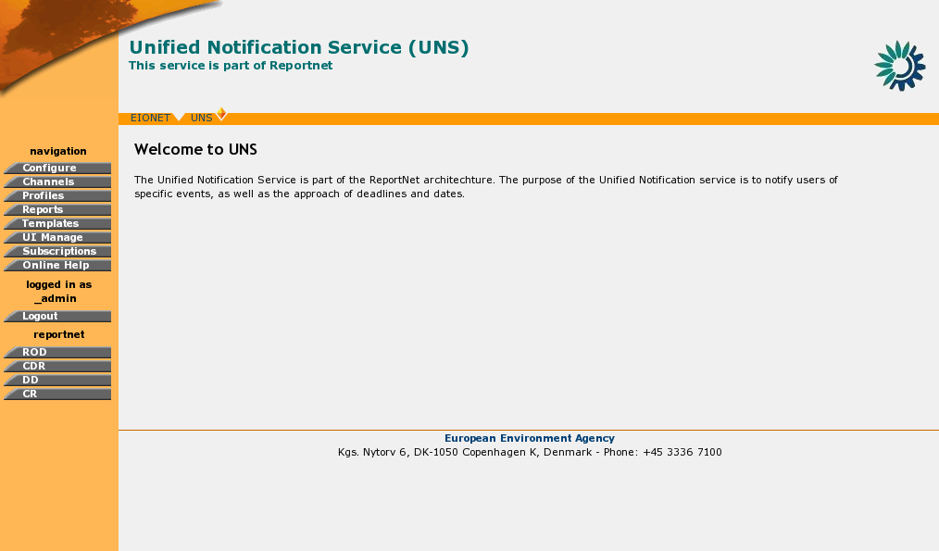

Figure 15 - The main screen of the UNS Administrative UI

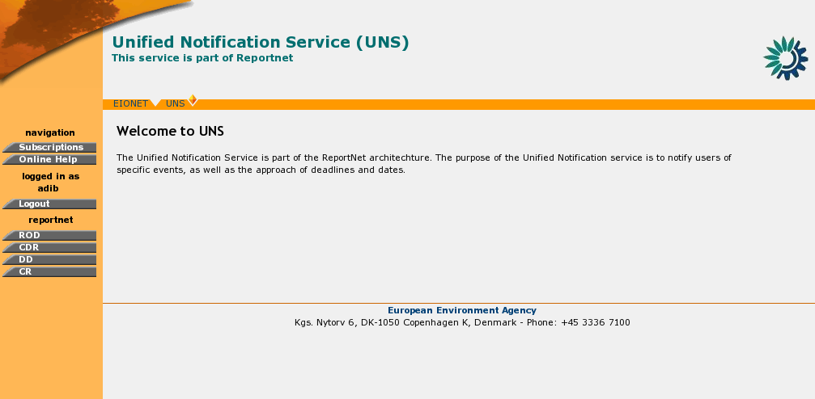

Figure 16 - The main screen of the UNS REPORTNET Users UI

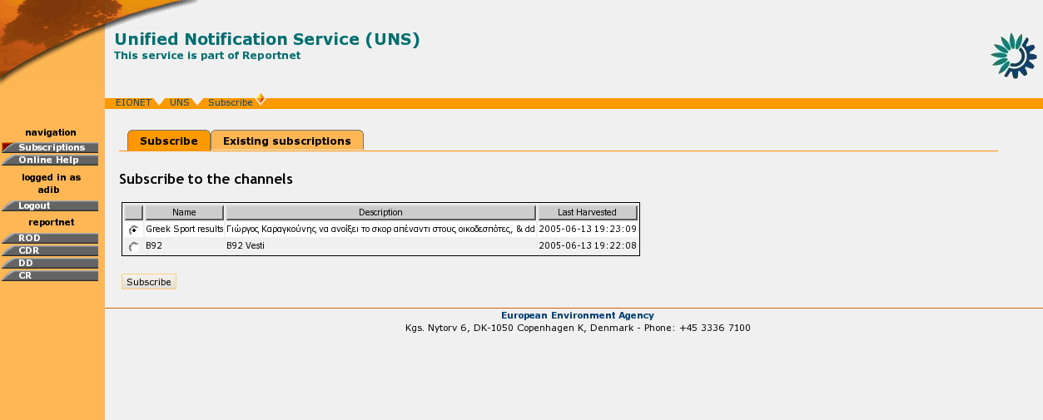

Figure 17 - UNS REPORTNET Users UI for choosing channel for subscribe
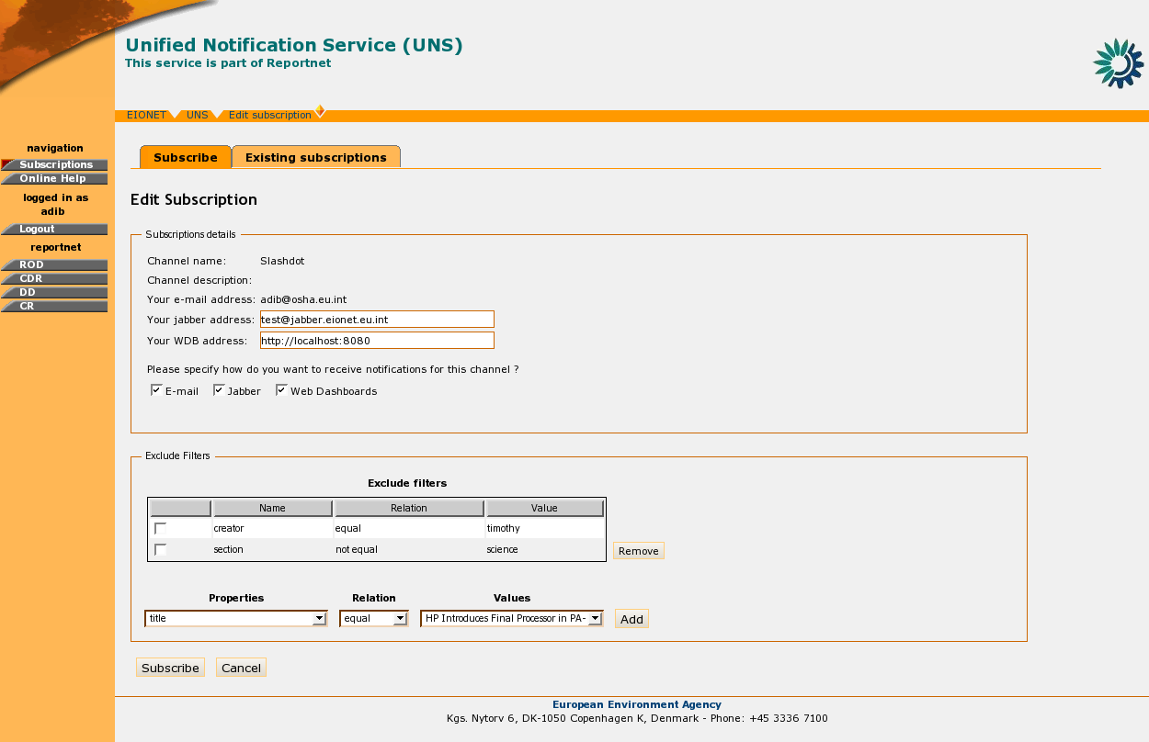

Figure 18 - UNS REPORTNET Users UI for providing subscription details

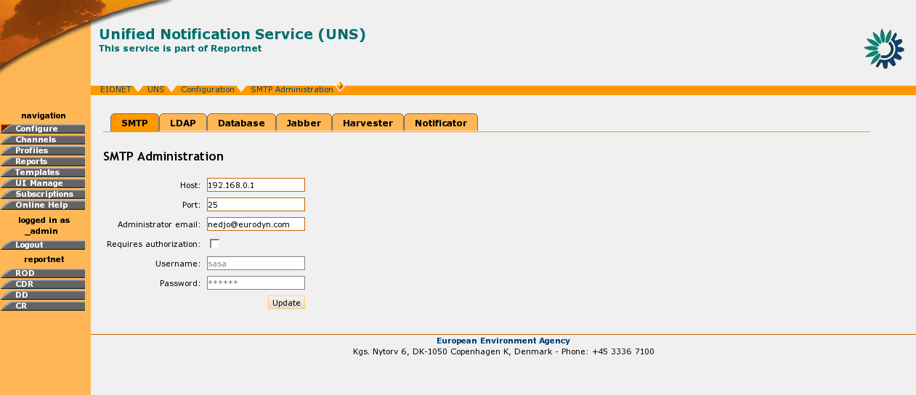

Figure 19 - Administrative UI for the setting up UNS configuration

Appendix B: Requirements Traceability Matrix
Nr | CfT Requriement | Related FSD requirements
1 | Harvest date and event information  from a number of Agency web applications | REQ-3.1.3-4  REQ-3.2.4.1.3-1 - REQ-3.2.4.1.3-4  REQ-3.2.4.2.3-1 - REQ-3.2.4.2.3-4
2 | Provide data and event information in an XML standard for use in the notification set-up web service, notification emails and summary web pages as well as in other web services such as the Eionet calendar and Reportnet dashboards | REQ-3.1.3-1 - REQ-3.1.3-3  REQ-3.1.4-3
3 | Provide user notifications, (including notifications to forewarn of events such as deadlines) based on user preferences, (including lead-time for forewarning of events). | REQ-3.1.4-1 - REQ-3.1.4-2  REQ-3.2.4.3.3-1 - REQ-3.2.4.3.3-7
4 | The web service will be composed of a web front-end interface for users to set-up their subscriptions and manage notifications for specific dataflows or countries or crosscutting events in the dataflow cycle in which they are interested in receiving notifications. | REQ-3.2.2.1.3-1 - REQ 3.2.2.1.3-4  REQ-3.2.2.2.3-1 - REQ-3.2.2.2.3-3  REQ-3.2.2.3.3-1 - REQ-3.2.2.3.3-5
5 | Define and manage a typology of notification profiles | REQ-3.2.1.3.3-1 - REQ-3.2.1.3.3-5  REQ-3.2.1.4.3-1 - REQ-3.2.1.4.3-3  REQ-3.2.1.5.3-1 - REQ-3.2.1.5.3-3
6 | Add content channels to the notification service | REQ-3.2.1.2.2-1 - REQ-3.2.1.2.2-5
7 | Administer the application and databases | REQ-3.2.1.11.3-1 - REQ-3.2.1.11.3-2  REQ-3.2.1.12.3-1 - REQ-3.2.1.12.3-3  REQ-3.2.1.13.3-1 - REQ-3.2.1.13.3-2  REQ-3.2.1.14.3-1 - REQ-3.2.1.14.3-3  REQ-3.2.1.15.3-1 - REQ-3.2.1.15.3-5
8 | Make modifications (add, edit or delete) content in the web front-end interface | REQ-3.2.1.10.3-1 - REQ-3.2.1.10.3-6
9 | Add, edit or delete additional text content and hyperlinks to emails sent as notifications | REQ-3.2.1.7.3-1 - REQ-3.2.1.7.3-3  REQ-3.2.1.8.3-1 - REQ-3.2.1.8.3-3  REQ-3.2.1.9.3-1 - REQ-3.2.1.9.3-3
10 | The notification service will provide a password protected web service that is integrated with Reportnet access control mechanisms, the Agency's LDAP directory services for members as well as other Reportnet modules | REQ-3.1.3-5  REQ-3.2.3.1.3-1 - REQ-3.2.3.1.3-3  REQ-3.3.1.0-5 - REQ-3.3.1.0-6
11 | The application should be based on the latest stable version of Zope and Zope products | REQ-3.3.2-2
12 | The scripting language for Zope applications must be Python | REQ-3.3.2-3
13 | The application should be based on the latest stable versions (approved by W3C) of XML, XSL, RSS/RDF, XHTML and CSS | REQ-3.3.2-1
14 | The application should have a well developed tool and library to  create templates for the website | Same as Nr. 9
15 | The website should be full screen automatically for screen size  of 800x600 pixels and up | REQ-3.1.1-2
16 | The website should be compatible with IE 5.0, NS 6,  Opera 7.0 and up | REQ-3.1.1-1
17 | The application layer should be based in ZOPE/Python-technology or equivalent. In the case of a Zope environment the solution may be extended with products like Plone, CMF, CPS and ZEO if necessary, to meet the functional requirements | Same as Nr.11 and Nr.12
18 | The preferable environment for Zope is Linux | REQ-3.3.1.5-1
19 | The application layer should have a modular design to meet  the functional features | REQ-3.3.1.4-2
20 | The application should include a software self-integrity  check and recovery | REQ-3.3.1-3
21 | The application and website should have a 98% up-time  (ie not more than 2% unplanned down-time) | REQ-3.3.1.1-7
22 | Password protection should allow administrative users to make  changes to designated sections of the site | REQ-3.2.3.1.3-1 - REQ-3.2.3.1.3-3
23 | The application should support around 1000 users with  notification profiles | REQ-3.3.1.3-2
24 | The application should support a notification through-put of 500  notification events per day | REQ-3.3.1.3-1
25 | The guarantee level for the delivery of notifications should be the  same as for email. (Non-receipt should be logged and be able to be displayed in the administrative interface. Problematic user accounts can be easily removed from the system by administrators) | REQ-3.2.1.13.3-1 - REQ-3.2.1.13.3-2  REQ-3.2.1.14.3-1 - REQ-3.2.1.14.3-4
26 | Response time for notifications to be issued following an  event should be less than one working day | REQ-3.3.1.3-3
27 | Notification service will uniquely identify "notification events"  in reporting dataflows and make these available for use in other web services via XML | Same as Nr. 2

[END OF DOCUMENT]

Action: I = Insert; R = Replace; C = Creation

